**Section 18 done: 22/22 Adding Authentication to our Burger Project**  
**Introduction**  
* I want to show you show authenticating users works in React SPAs (Single Page Applications).  
* Because if you have a Multi Page Application, where you render different pages for different Requests from your server, you handle authentication in the traditional way of having a SESSION on the server and returning different pages after checking the authentication status of the user on the server.  
* Now the special thing about authentication in React is that you have only 1 file and thereafter you get no new file.   
* So you can check the authentication status of the user on the server but not on every Request, at least not in the traditional model.  
**Understanding Authentication in Single Page Applications**  
* The SPA sends the authentication data to the server because we probably have a sign-up or sign-in page in our SPA and therefore we get data like the email address and the password and we send this to the server to validate it there because such logic obviously always has to happen on the server and this is also where we store our persistent data - in the database, on the server. And the server doesn’t have to be Firebase as in our project of course, this can be any server, any RESTful API to be precise. This is typically what we communicate with when using SPAs.  
* That server then sends something back - and you could think that’s a SESSION. But since the server in an SPA world typically is a stateless RESTful API, we’re not getting back a SESSION because the server doesn’t care about the different clients connecting to him.   
* Instead we get back a TOKEN. You can think of that TOKEN as a JavaScript object encoded as JSON.  
* JSON web tokens are the typical form of tokens you get.  
* So it’s a JavaScript object in the end you can say and this object now has to be stored on the Client. For example in LOCAL STORAGE. We could also store it in our Redux STORE but there it’ll be lost whenever the user refreshes the page so we typically use LOCAL STORAGE since that persists page refreshes and allows us to fetch that TOKEN even if the user did leave and revisit our page, so that we can leave the user logged in if we want.  
* And what do we need this TOKEN for then?  
=> Well imagine we’re making Requests to some protected resource on the server - like for example we try to change our password or we want to create a new blog post. Such Requests are of course only allowed for authenticated users and since we don’t constantly check the authentication status on the server - we have no SESSION there, we pass the TOKEN along with Requests to such protected resources.  
=> **That TOKEN - and that’s important - is created by the server and in a way that the server can verify if it’s a valid TOKEN, created by the server or not**, so that we can’t fake such a TOKEN on the Client, we can’t create it there and send it to the server, that would not work. Only the TOKEN sent by the server is accepted on the server.  
* So this is how we then authenticate ourselves on subsequent Requests after receiving that TOKEN and that’s the pattern we’re going to implement in our this module.  
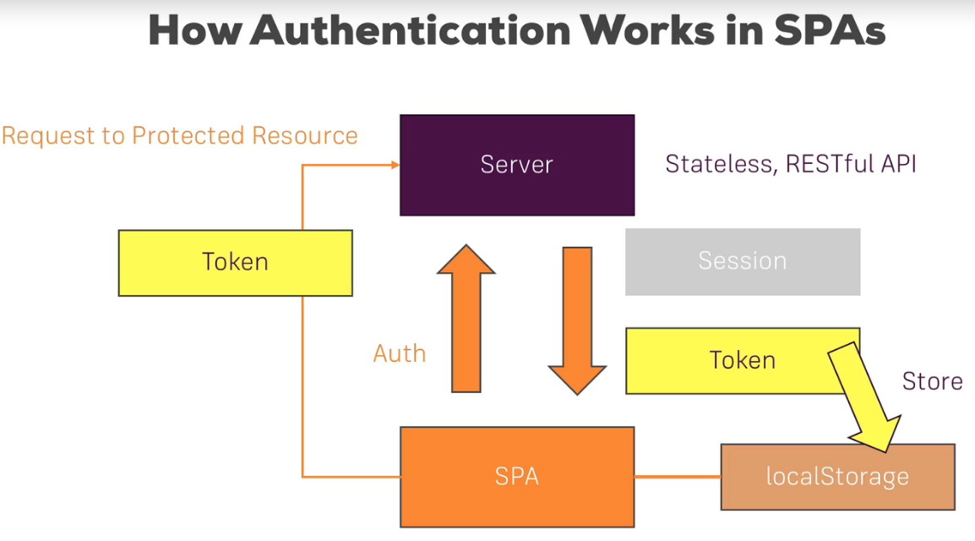  
* **We’re going to use Firebase because it’s so easy to set up but that pattern is going to be the same no matter which Back End you use, as long as it’s a RESTful API**.  
* So what are the required adjustments in our application then?  
**Required App Adjustments**  
* There are some things in our Burger Builder project which we’ll adjust in this module.  
* We need to add a new view - the Signup & Signin - I’ll combine it in 1 view, where we can create new users or log users in.  
* We also want to protect some ROUTES on the Frontend - GUARD them so that for example we can’t access the “Orders” route if we’re not authenticated.  
* And additionally I also want to pass that TOKEN we’ll receive, onto the Back End for Requests to protect that resources so that we can make sure that this does not work.  
* These are the adjustments we have to make on our Front End.  
* First of all we’ll start with the Signup & Signin view.  
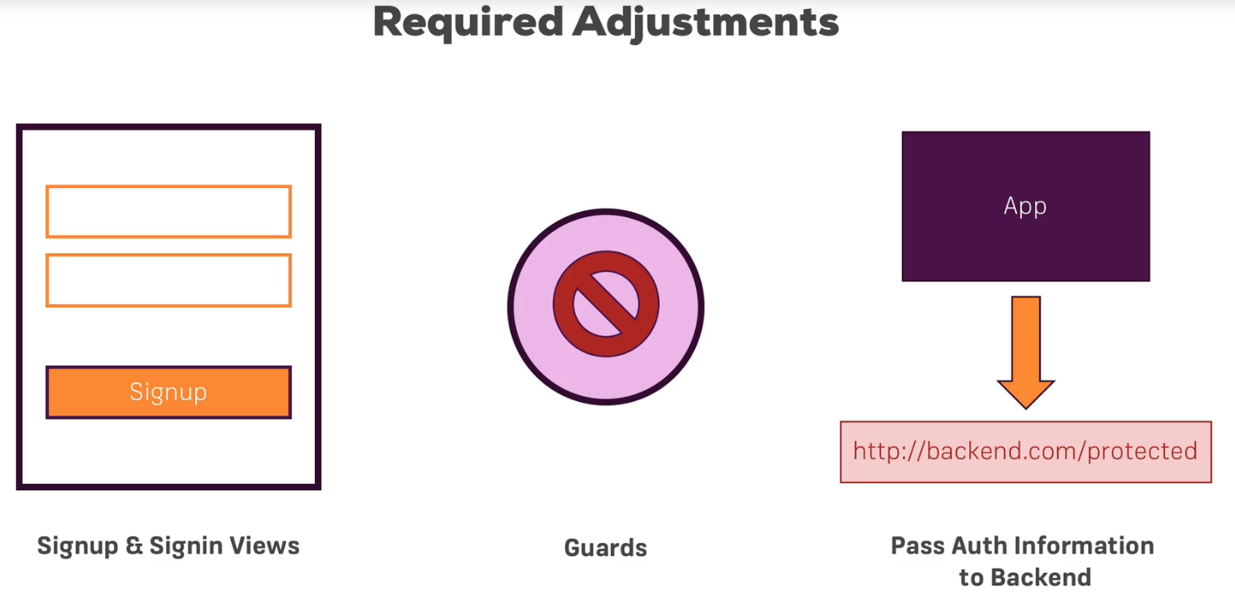  
**Adding an Auth Form**  
* I’ll add a new container in the `containers` folder - Auth.js.  
* This will be the page I want to load with the Signup or Signin form.  
* This JSX here will be pretty close to our ContactData form.  
* I’ll also manage my form through the STATE of this Auth.js container - not through Redux because I’m only talking about the Local State and it makes more sense to me.  
* I’ll set it up kind of equally to the ContactData so that I can reuse the logic from there.  
* Regarding the rules, I want to use the checkValidity method from ContactData.js and there I support things like: required, minLength, maxLength, isEmail and isNumeric and that is basically what I want to introduce in the Auth.js container too.  
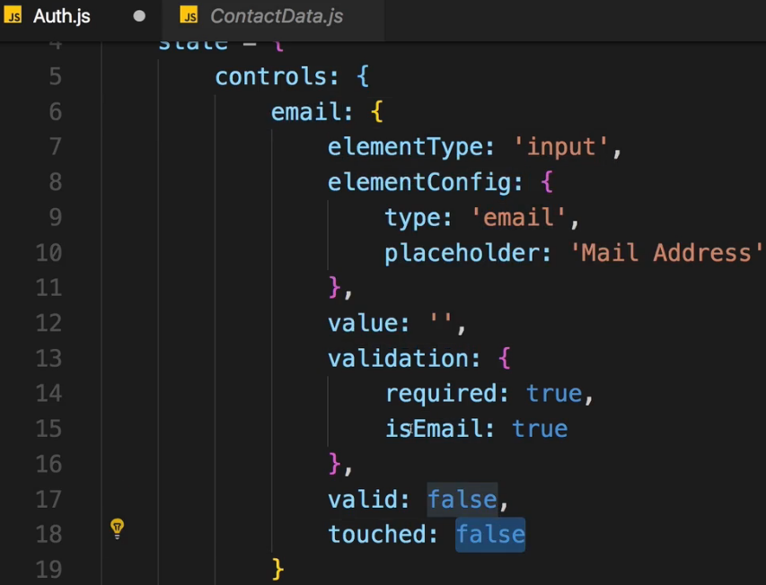  
* Now I will duplicate this once to also have a password field.  
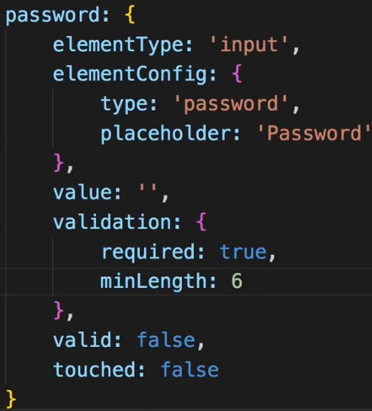  
* We can now dynamically create that form.  
  
* Now the logic is the same as in the ContactData container - there we also looped through all our controls and I can therefore copy the code from there where I convert it - my state object - to an array I can loop through.  
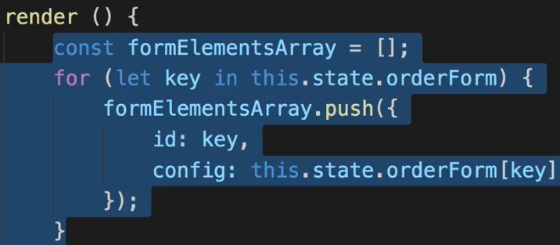  
* Now in Auth.js I want to loop through it and create my form.  
* The ID is the name of the element.  
* We can copy all the props setup from the ContactData.  
* We can also leave the code as it is because I kept the name and the setup.  
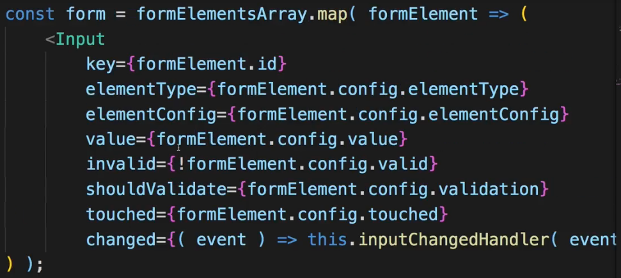

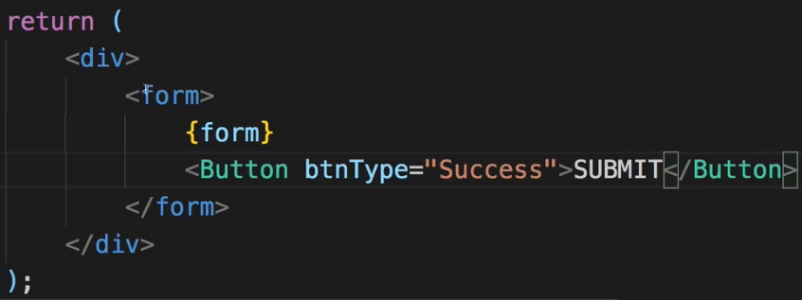  
* To see it, we need to load it via ROUTING.  
* We set up all our Route-s in our App.js file.  
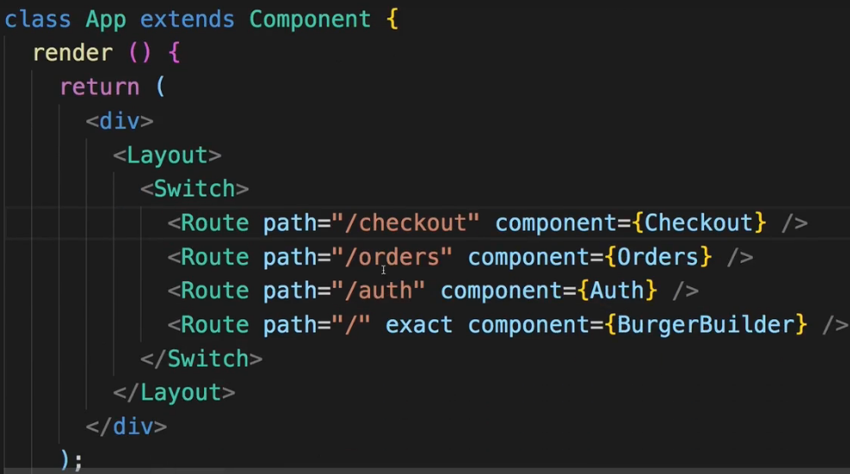  
* To be able to reach that, I’ll also go into my `components` folder and there to NavigationItems.js component.  
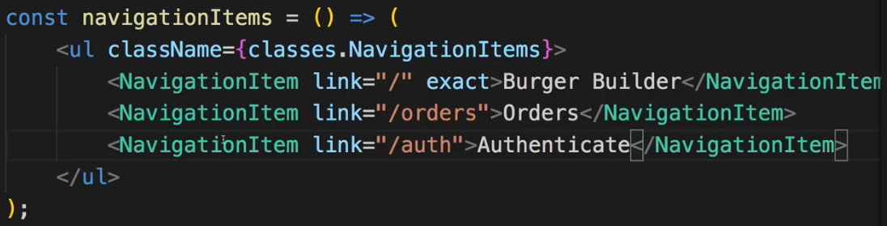  
=> Right now we can’t see the Inputs.  
=> The reason is because I copied the code from ContactData.js, I’m referring to `this.state.orderForm` property but here in the Auth.js I renamed this to `controls`.  
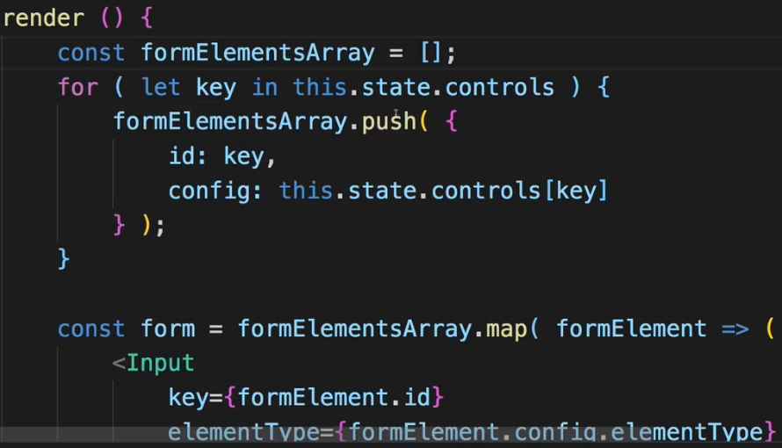 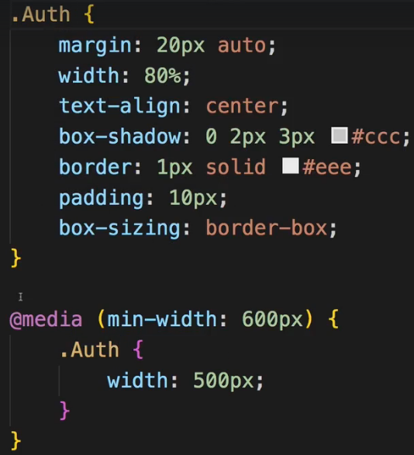  
* Now we see the controls.  
* Now to also give this some styling, let’s add Auth.css file. I’ll copy the styling from the ContactData.js and just rename it.  
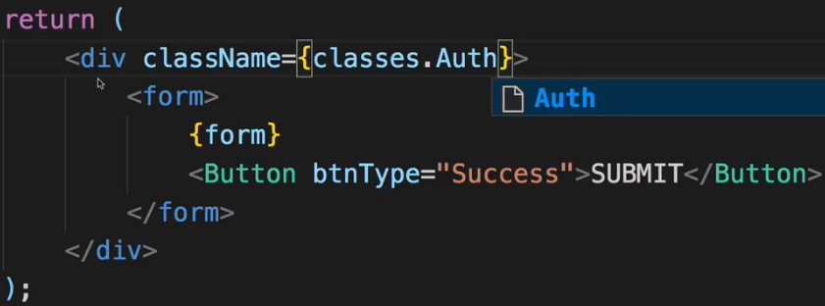   
* So this is the Signup form.  
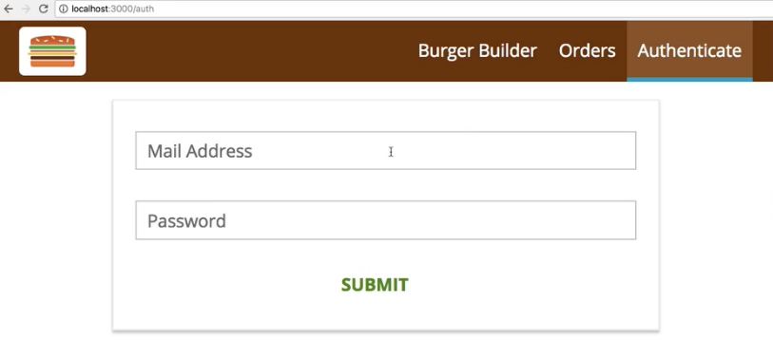  
* The next step is to also configure this form to have validation.  
=> I will also copy the code for this from ContactData and by the way with all this code copying you’d correctly say: can’t we outsource some of this code in some centralized file? And yes we can, we’ll do this in the next module where we’ll apply some optimizations to this project.  
* For now I’ll just grab the checkValidity() method.  
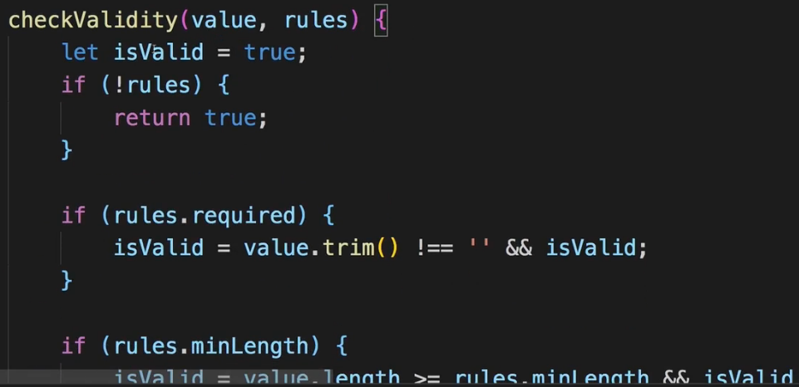  
* And now I need the inputChangedHandler and I’ll also get this from ContactData.js - I can use a lot of the logic BUT NOT ALL form the ContactData.js inputChangedHandler.  
=> I want to create an updated form where I update my elements but I’ll do it manually here in the Auth.js container.  
* I want to update only 1 of the controls - the control with the controlName we have here.  
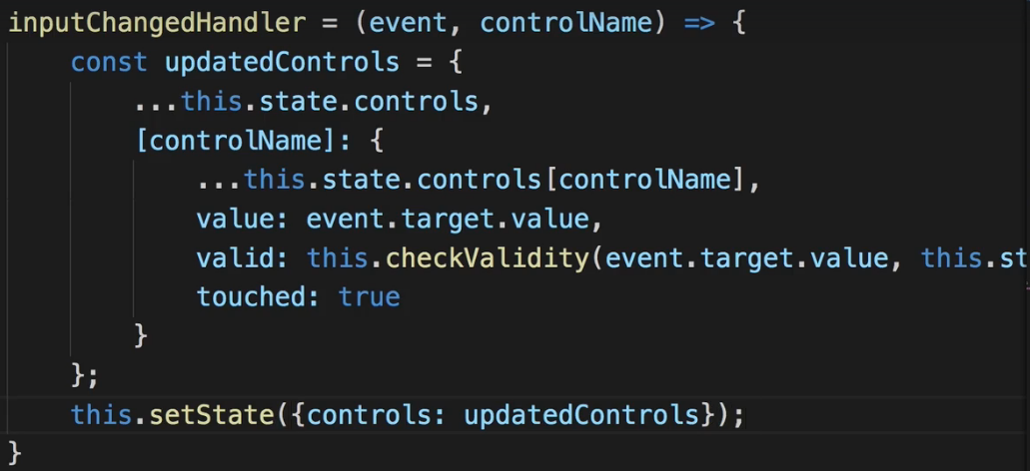  
* Now I deliberately won’t handle the overall form validity here, I won’t check this, I won’t disable the “SUBMIT” button for invalid forms because I also want to show what happens if we submit invalid forms. You can of course implement this too but I won’t.  
* Now I need to connect it - I already did this because I used the same name as in ContactData.  
* The next step is to handle the submission and of course I want to do this using Redux and ACTION CREATORs.  
**Adding Actions**  
* Let’s add ACTION CREATORs because of course I want to dispatch() an ACTION when the “SUBMIT” button is pressed.  
* In `store` `actions` folder I’ll add auth.js file.  
* There I want to set up authentication-related ACTIONs.  
* I’ll also set up some ACTION TYPEs in actionTypes.js file.  
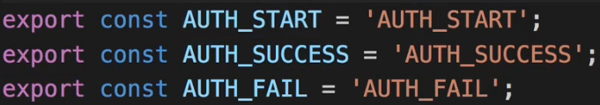  
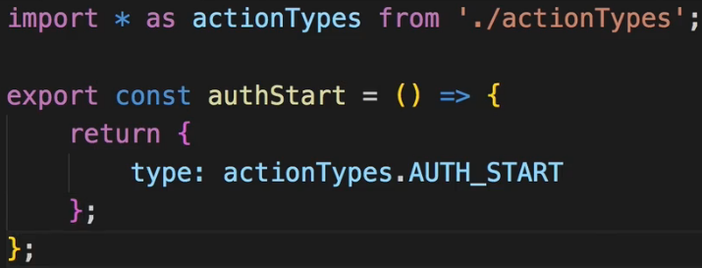  
=> I’ll essentially use this ACTION to set a `loading` state and potentially show a Spinner if I want to.  
* We’ll have a look at what the `authData` is later.  
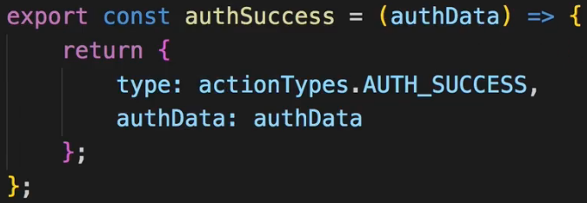  
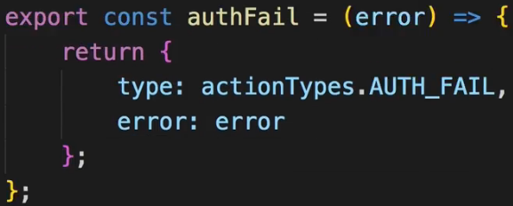  
* I’ll add 1 last ACTION CREATOR, that’ll be the one holding the Asynchronous code, doing the authentication.  
* I’ll return `dispatch` so a function which gets dispatched as an argument thanks to redux-thunk.  
* In there I now want to authenticate the user.  
* Now for now I’ll simply dispatch() authStart() here to at least set this state.  
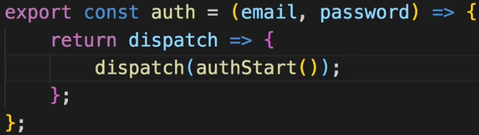  
* Now of course we need to connect our ACTIONs to our container so that we can dispatch() them.  
* To import the ACTIONs let’s add them to the index.js file in `actions` where I bundle all my exports.  
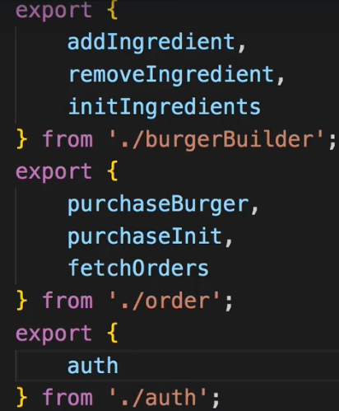   
* Now we can add mapDispatchToProps to be able to dispatch() something here via props.  
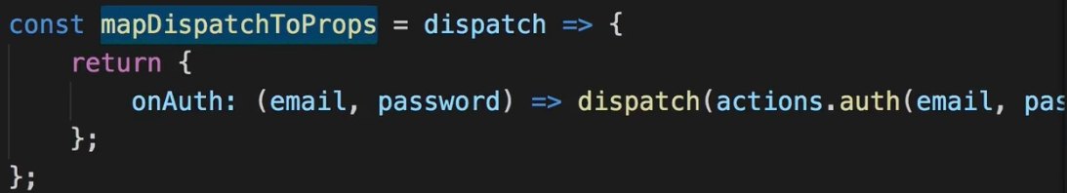   
* Now we need to connect it to this container.  
  
* With that we can execute `onAuth` in this container and I want to do this whenever the form is submitted.  
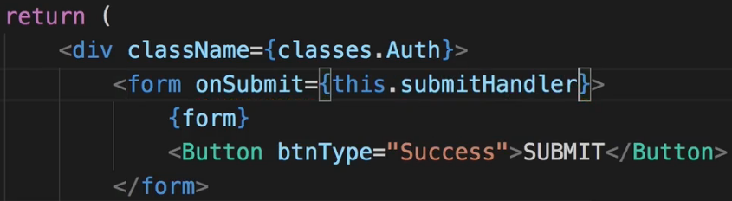  
* I’ll add this method to this container.  
* We need to call event.preventDefault() to prevent the reloading of the page.  
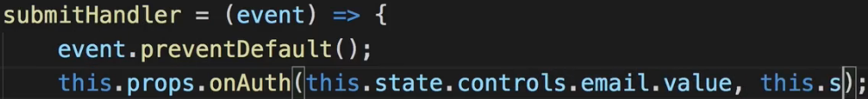 this.state.controls.password.value  
* If I click submit and inspect Redux Devtools, we see that AUTH_START was dispatched successfully.  
* The next step is to run some Async code which actually does authenticate users, using Firebase.  
**Getting a Token from the Backend**  
* The approach works with any Backend given that the Backend has appropriate API Endpoints to connect to.  
* If you’re looking for instructions on how to validate a user email on the server, how to create that token, that’s the wrong course - this is nothing to do with React and therefore isn’t covered here, a general API building course for your server-side language of choice would be more appropriate.  
* I’ll show you the React side.  
* And Firebase gives us authentication out of the box.  
* Firebase > Authentication > Set up a sign-in method > email/password for our project.  
* And now we can reach certain REST API Endpoints to sign-up users and get a TOKEN.  
* > google for: Firebase REST Auth and it’s the Firebase Auth REST API | Firebase link.  
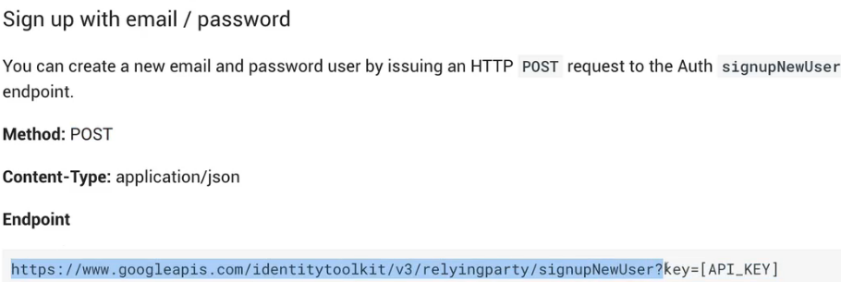  
* And now I want to send the Request.  
* We could create another Axios instance for this - we definitely can’t use the axios orders instance because there we have a baseURL which would be wrong - but I’ll use the default axios service and not an instance. I’ll only send 2 Requests so I don’t really need to set up that baseURL thing.  
* In auth.js let’s import axios:  
* We need to replace the key=[API_KEY] with the API KEY of our Firebase project.  
* Firebase > Authentication > top right WEB SETUP, it’s this apiKey:  
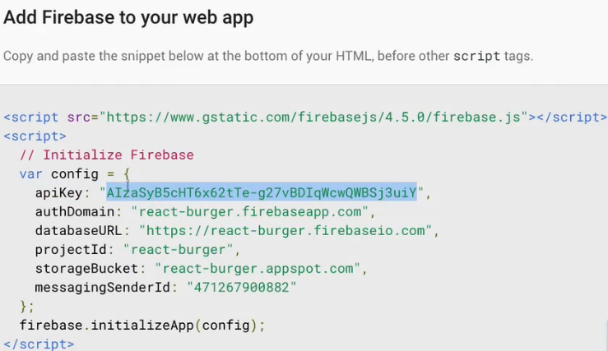

* This identifies your application to Firebase.  
* The data we need to post can be found in the documentation we were just on, we need to pass a JavaScript object which will be transformed to JSON by Axios automatically, which has an email, a password, and this returnSecureToken property:  
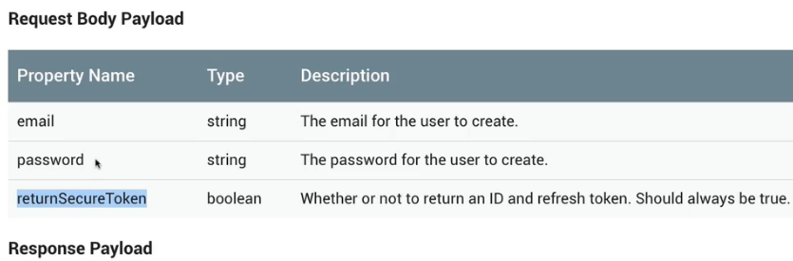  
* We pass authData as the 2nd argument to the axios.post().  
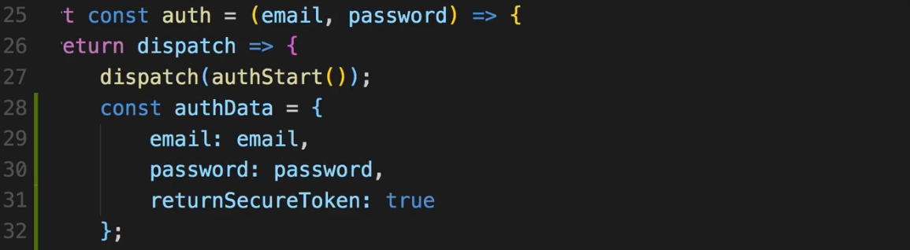  
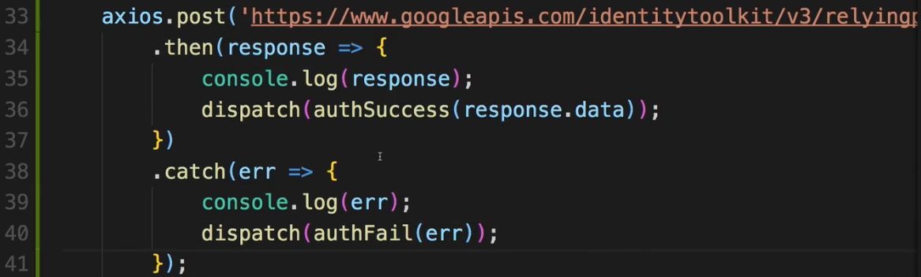  
* If we now submit the form, we see AUTH_START and AUTH_SUCCESS.  
* And we got the response:  
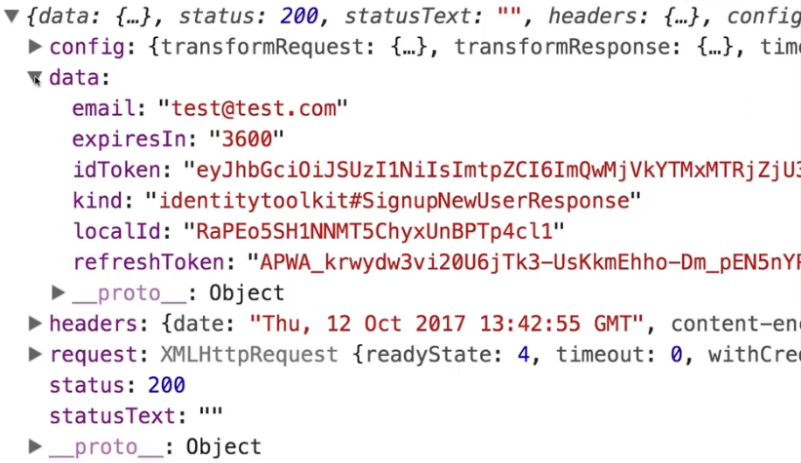  
=> We got information how long the TOKEN is valid, so 3600 seconds, that’s 1 hour.  
=> Then the ID TOKEN itself - this long cryptic string which can be decrypted to a JavaScript object if we want to.  
=> Then this REFRESH TOKEN which is used to get a new ID TOKEN because as you can see the ID TOKEN expires relatively fast - after 1 hour - for security reasons, but you can generate a new one with the REFRESH TOKEN but only you in your application can do that of course.  
* And in Firebase in Authentication if we refresh, we can see the user.  
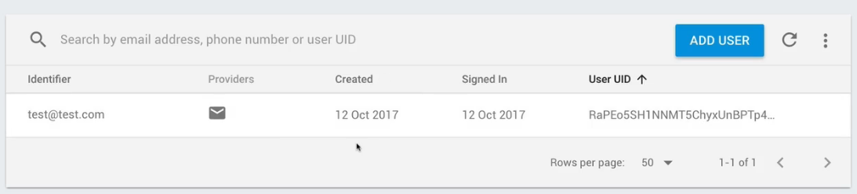  
* So this is how we sign users up and I didn’t add validation so if we enter an invalid pasword we can still click the “SUBMIT” button, now we get an error in the console and in the error - if we look at the ACTION in Redux Devtools:  
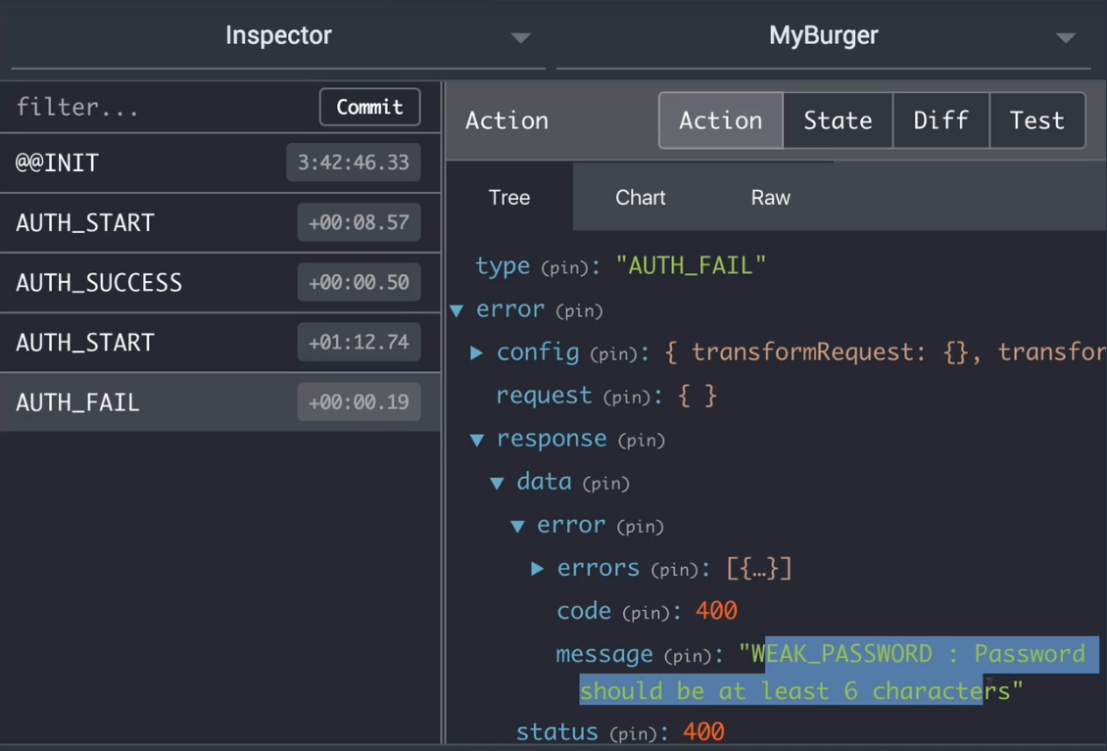  
* But if we enter valid information, the important thing is we got the ID TOKEN and REFRESH TOKEN.  
* We should use that information to authenticate ourselves for subsequent Requests but before that, let’s make sure that we can also log-in.  
**Adding Sign-In**  
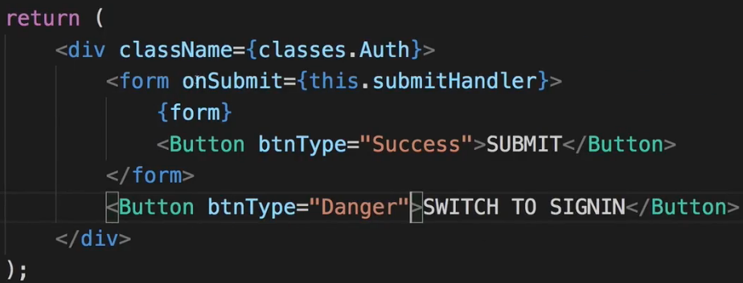 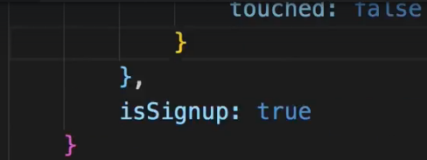  
* And now I want to manage the state here in my state in this component.  
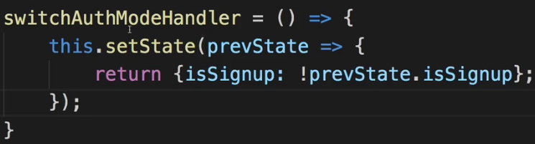  
  
* And we add the method to it:  
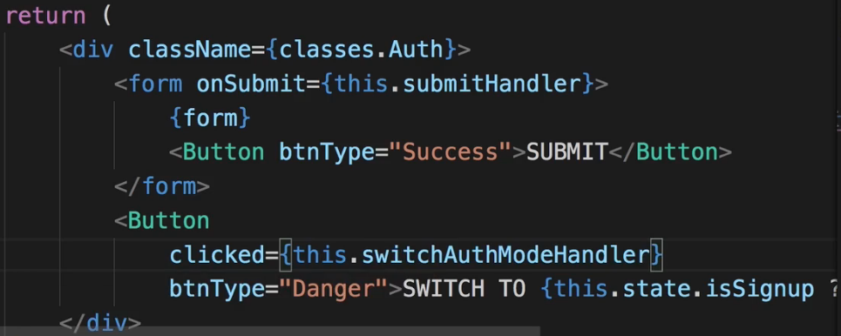  
* Now we can switch between the SIGNUP and SIGNIN.  
* Of course this doesn’t really do anything, for this to have an effect we need to do something different on the submitHandler(). We always call onAuth where in the end we always execute this AUTH ACTION and that actually is fine, I just expect to get a 3rd argument here, that’s the `isSignup` for example if it’s SIGNUP or SIGNIN, and I will simply send the Requests to different URLs for different ` isSignup`.

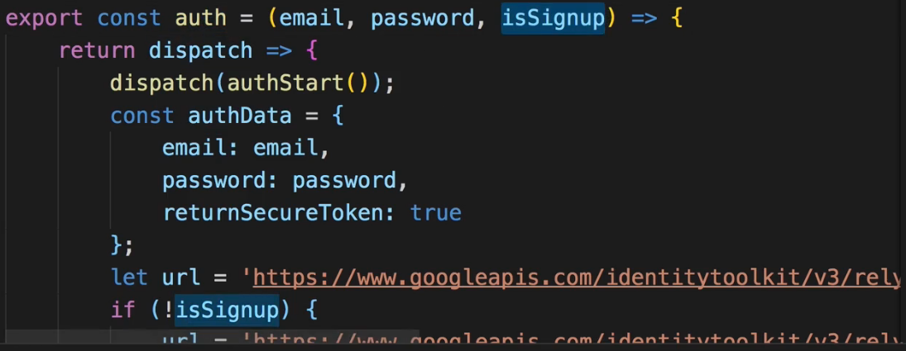  
  
=> The last step is to pass that isSignup on to the ACTION CREATOR.  
* In Auth.js container:  
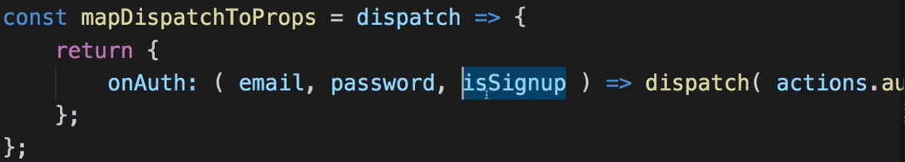 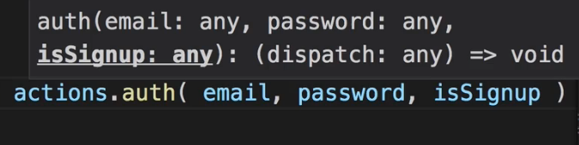  
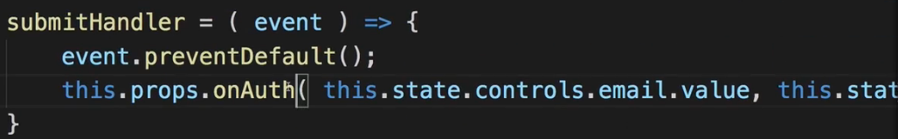 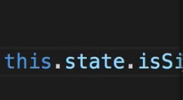  
=> isSignup is information I can pass when I call this property in my submitHandler() because I of course store this in my state of this container.  
* Now in our application if we try to enter the same email/password, we get an error because that email address is already in use.  
* However, if I switch to SIGNIN and I “SUBMIT”, we see SUCCESS and we get back authData with the TOKEN and so on because we do successfully sign in here.  
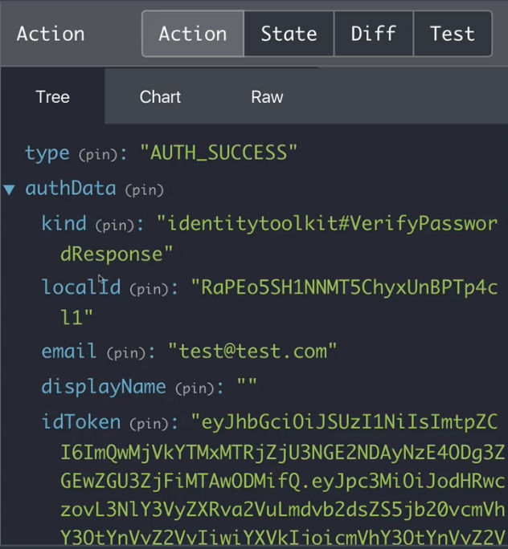  
* The next step is of course to store that TOKEN so that we can also use it in the future.  
**Storing the Token**  
* We want to store this TOKEN to be able in the future to also access resources on our server which are protected.  
* To store the TOKEN let’s go to `reducers` and create a new REDUCER auth.js.  
* There I want to handle all these auth ACTIONs and my auth state.  
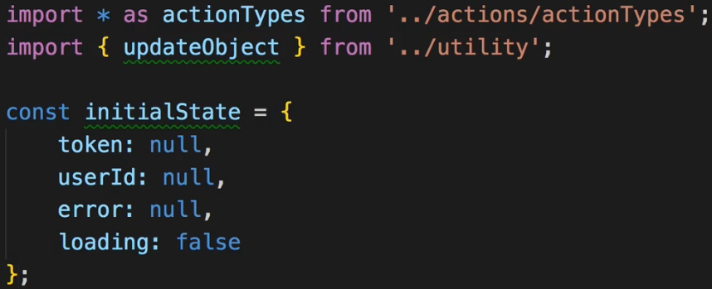  
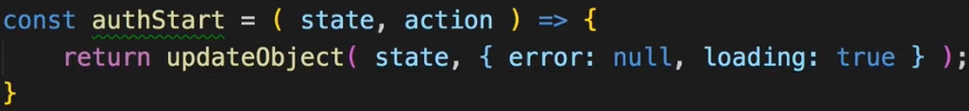  
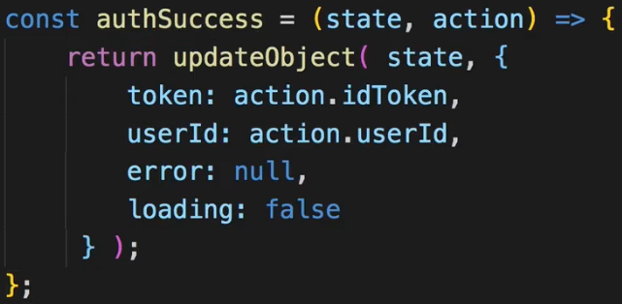  
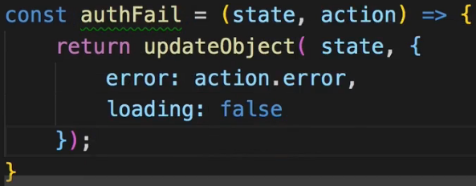  
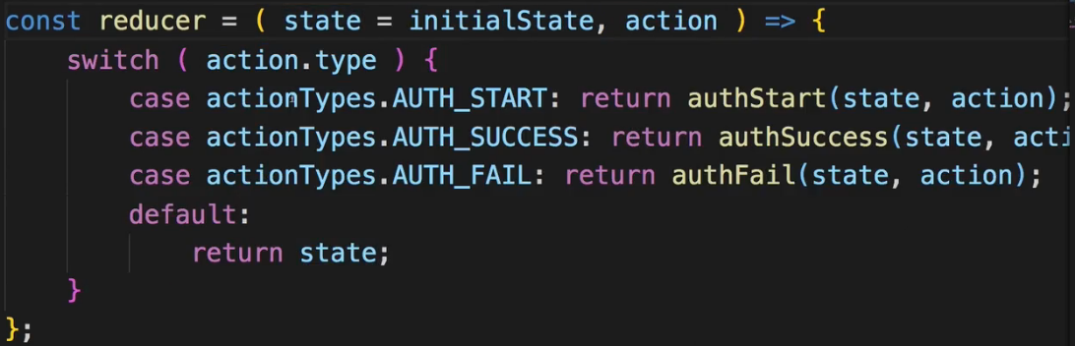  
* Let’s optimize the `switch case` statement to be lean like in the other REDUCERs.  
* With that I got a nice auth REDUCER which should be able to do something with my data.  
* Now of course I want to combine it with my other REDUCERs.  
=> So in the main index.js file:  
  
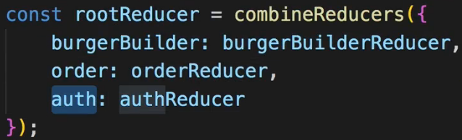  
* With that we added to our global ROOT REDUCER.  
* We won’t get all the information we want though.  
=> idToken, userId - I extract all of that from the `action` but right now in our ACTION we’re not passing on that data. So let’s inspect the `response` we get back to see how we extract the data we want to pass on, to authSuccess() and so on.  
* This is the `response` for SIGN IN:  
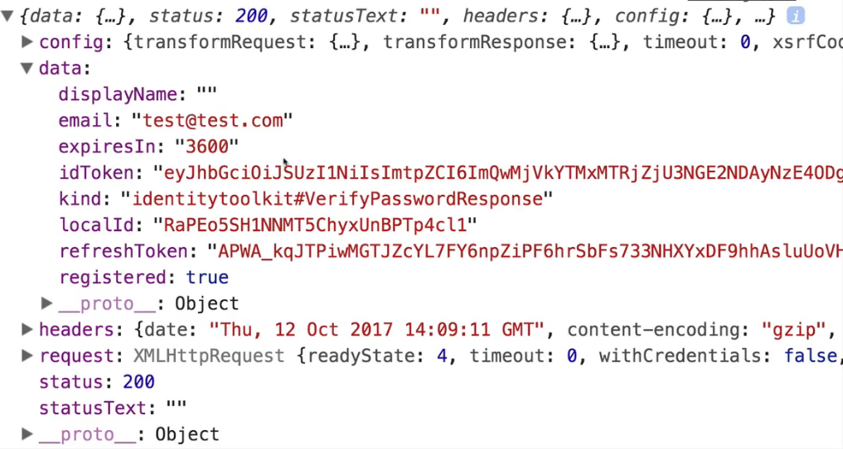  
=> Here we see the `localId` which is the user ID and we get the idToken that’s also interesting to us.  
=> So these are the 2 things I’ll save. I won’t save the refreshToken so refreshing the token won’t be possible here, this is something you would have to do if you want to ensure that TOKENs don’t expire after 1 hour.  
* In my app, people will need to log-in again after 1 hour.  
* So to save that data, the localId and idToken, I get that in my auth.js file in `actions` folder here where we axios.post() our authentication Request and get back a response - in `response.data` we have these 2 fields. And I need to pass this on to authSuccess because authSuccess then needs to pass it on.  
=> In authSuccess instead of authData let’s take token and userId as arguments so that I can pass them on as props which I can then try to extract in my REDUCER.  
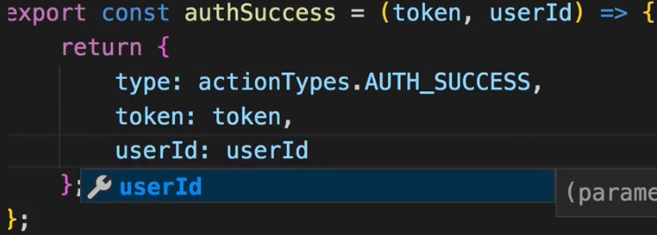   
* This is the REDUCER auth.js:  
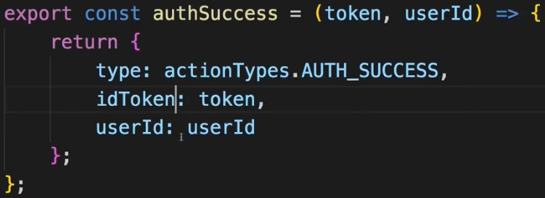 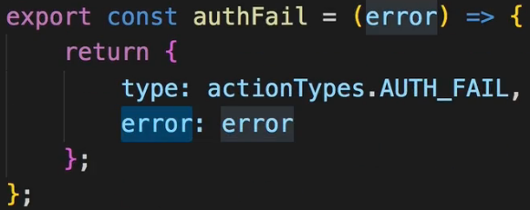  
* With that we need to go back to auth.js in `actions` and I do expect to get my token and userId in the authSuccess function, that of course means that when we dispatch() this function here in the auth ACTION, I need to pass it on:  
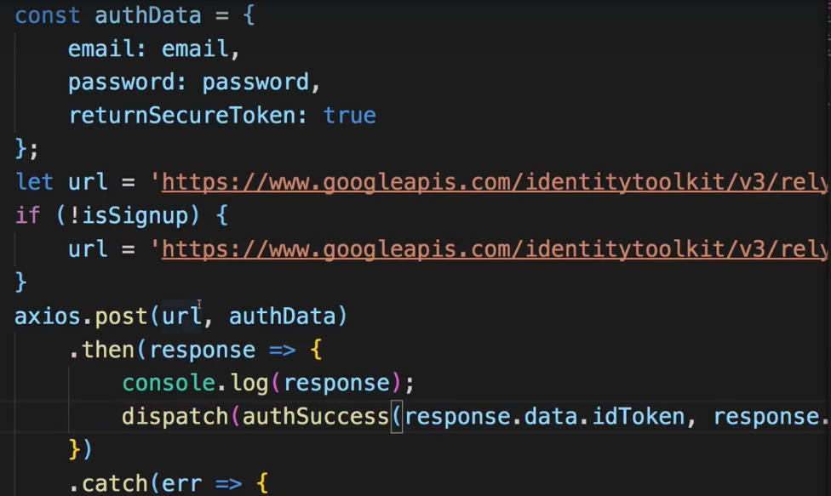  
* Now it worked and we have the TOKEN and user ID stored in our `auth` state in our STORE.  
* With that we’re storing the authentication status.  
* What we’re not doing is we’re not showing a Spinner while we are authenticating. Let’s add this as well as error handling before we continue and make use of that TOKEN when trying to access resources we otherwise wouldn’t be able to access.  
**Adding a Spinner**  
* Let’s add a Spinner and also if we enter something invalid, let’s get a visual error feedback.  
* Auth.js container:  
* I want to display the Spinner as long as we’re loading. And for that I need to know if we’re loading and we’re storing that information in our `auth` state in auth.js REDUCER.  
=> For that I need to get a piece of that state.  
=> Adding mapStateToProps there we get the state and can now map a slice of it to our local props.  
* **We have to use `state.auth` because that leads to the AUTH REDUCER in combineReducers**.  
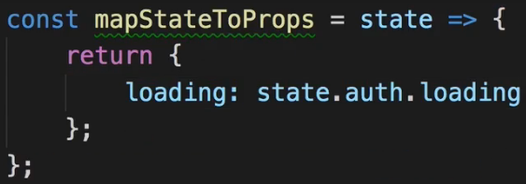 

* Now here in our render() we can render the Spinner.  
* So we render either the form or the Spinner depending on the `loading`.  
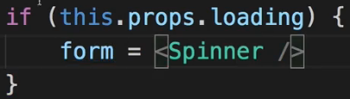  
* Now the Spinner works, even though it’s really brief because Firebase is really fast.  
* Now let’s make sure we see visual error messages.  
* And to see that I of course need to take advantage of the fact that I do store potential errors in my STORE.  
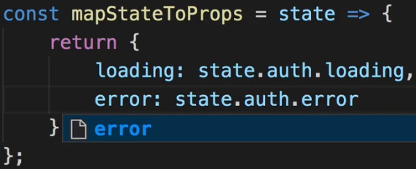 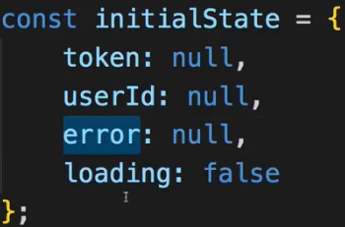 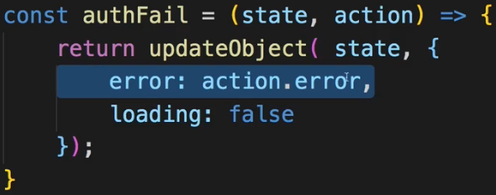  
* Now back in Auth.js container:  
* Firebase gives us a nice error message, your Backend might also do this or you craft your own one.  
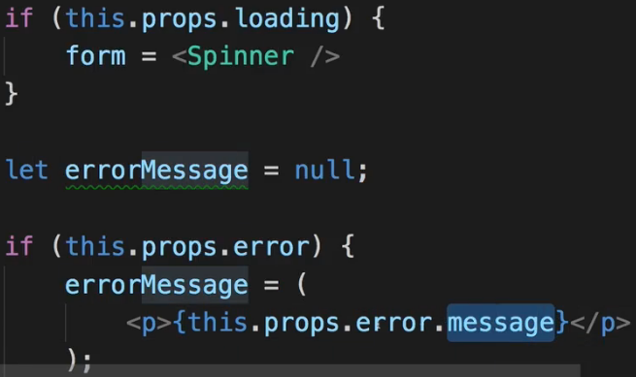  
* This message property is only available because I’m using the `error` as it comes back from Firebase and that happens to be a JavaScript object which has a `.message` property.  
* Now of course we could give this some styling.  
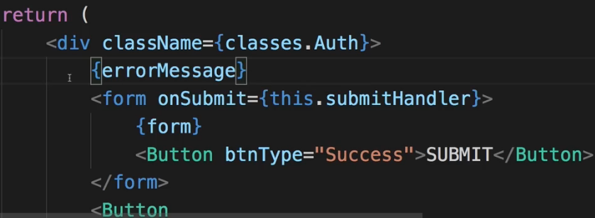  
* Now before we see something though, we have to ensure that we really store that error.  
* In auth.js `actions`:  
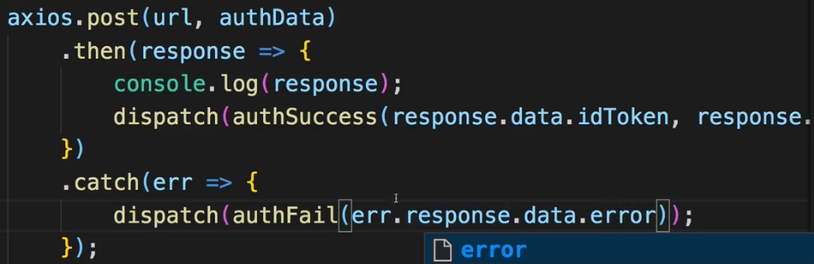  
* .response to access the original response, that is due to axios which simply wraps the response in this `error` object and there still we will have `data` and then this `error` object. So we get the same fields as on a normal response, just with an error code.  
* So now we can get error messages above the form such as: INVALID EMAIL or EMAIL_EXISTS.  
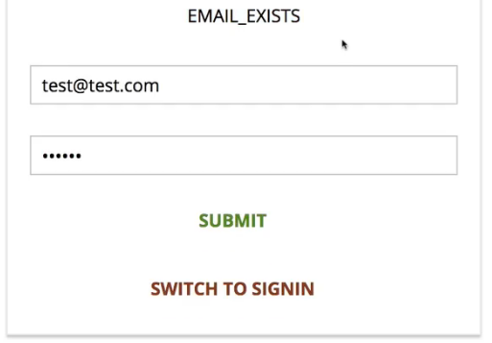  
* Now obviously it would be nicer if we get nice text we can easily read - you can of course map these code to your own error messages - it is something I won’t do here for now but definitely something you can keep in mind as an improvement.  
* You can always find out which potential errors you can get by having a look at the Firebase Auth REST API documentation. For example too many attempts.  
**Loggin Users Out**  
* When we sign-in and inspect the data we get back, there we have this expiresIn value. So the TOKEN is only valid for 60 minutes. After that whenever we send it to any resource which requires a TOKEN, the Request will fail as if we had sent no TOKEN at all. Now this is not the best User Experience, we probably want to actively log the user out after this hour.  
* As a side-note: if the user reloads the application, the state is lost anyway because that clears the Redux STORE since the entire application reloads.  
* So there we can then change the UI anyways - which we’ll do in the future - to show that we’re not logged in.  
* **But it is the state that we are logged-in and don’t reload the page for 1 hour where we can get into this strange spot of having a TOKEN which is not valid anymore, without us seeing that**.  
=> For that reason what I want to do is: I want to add some code to invalidate that TOKEN after 1 hour so that we then can also update our UI once the TOKEN is no longer there.  
=> To do that let’s go to auth.js in `actions`:  
* We want to run some Async code.  
* I will dispatch() this checkAuthTimeout ACTION when we get back a success response.  
* That expiresIn holds a string which can be parsed as a number.  
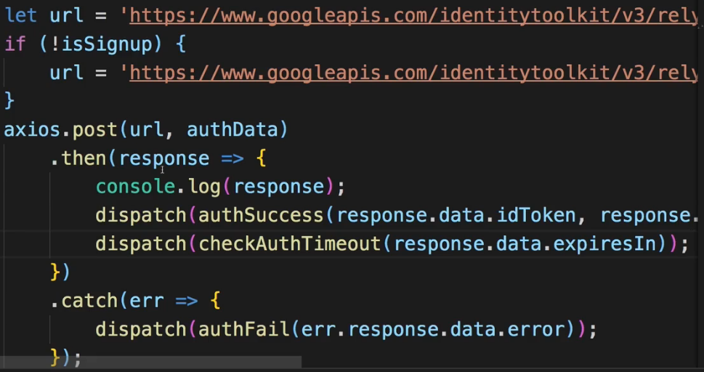  
  
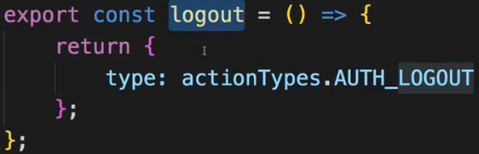  
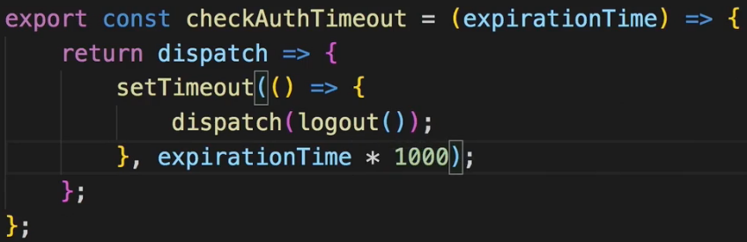  
=> **We do execute the function because that then returns the ACTION which is actually dispatched**.  
* Now in auth.js REDUCER:  
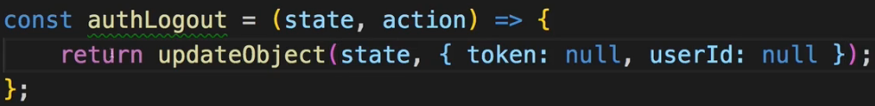  
=> Now I’m essentially logged out because all that core information that made up a logged-in user is now lost again.  
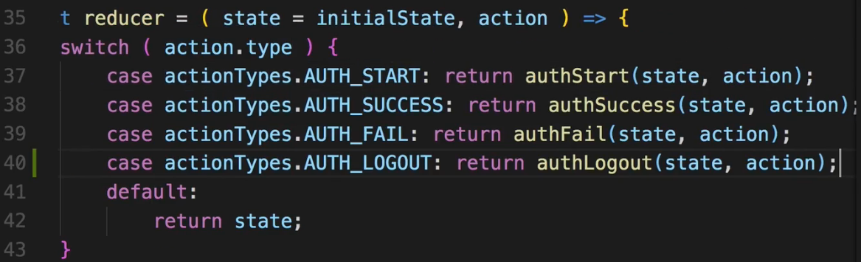  
* And with that we got this timer in place in our auth.js ACTION CREATORs file in checkAuthTimeout, which will fire after whatever Firebase returns us in expiresIn and which will then ensure that the user is logged out.  
* And for now this will clear the STORE and not do much else, it won’t show any visual feedback, but we will implement something to happen when the user logs out, including when he deliberately logs out to give the user a clue that he’s not logged in anymore.  
* Of course setTimeout works with miliseconds so we need to * 1000.  
* All works.  
* We can now continue and now finally take advantage of our TOKEN to protect some of the resources on our Backend in the first place, then still reach them and then of course also update our UI to for example add a log-out button to allow the user to log out.  
**Accessing Protected Resources**  
* That’s of course a typical use case - you have a Backend with certain API Endpoints which should only be usable by authenticated users.  
* Earlier in the course we changed our rules in Firebase to grant read and write access to everyone:  
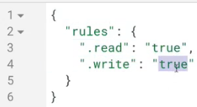  
* We did this to be able to use that database without having authentication.  
* Now of course this is Firebase specific that you do it with these rules setup, for your own Backend where you write your own API code, you probably have some IF check where you check if some valid TOKEN is attached to the Request and you simply return a 401 answer if that’s not the case.  
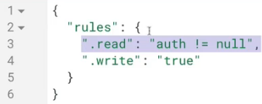  
=> In the simplest case we can set this to `auth != null` which simply means: if `auth != null`, then read access is granted. Put in other words that means if you’re not authenticated, then `auth == null` therefore this returns false and you don’t get read access. The same can be done for write access.  
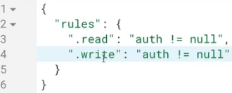   
=> If we set it up like this, this is applied to the entire database, to all the data that’s in there.  
=> I want to grant access to `ingredients` for everyone and just make access to `orders` only available to authenticated users.  
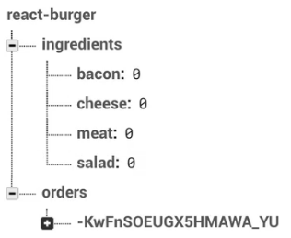  
* So we can fine-tune our rules:  
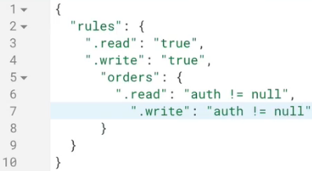 => And we PUBLISH these rules.  
* However, if we do it like this, our top-level read and write rules would still overwrite this for any nested nodes so I actually have to get rid of that and instead I’ll add a separate rule for my `ingredients`.  
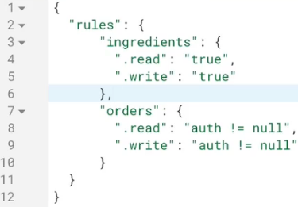  
* Now if we reload the application and go to orders, we get an error. The Burger Builder still works.  
* Now let’s make sure we can still reach orders if we are authenticated and have a TOKEN.  
=> To do that I need to go to the place where we actually send this orders Request.  
=> In order.js ACTION CREATORs file.  
* The TOKEN is store in our Redux STORE. How do we get it here inside our fetchOrders ACTION CREATOR?  
=> Now of course in this ACTION CREATOR we could also get the getState along with the dispatch, which you can execute to get access to the state/STORE:  
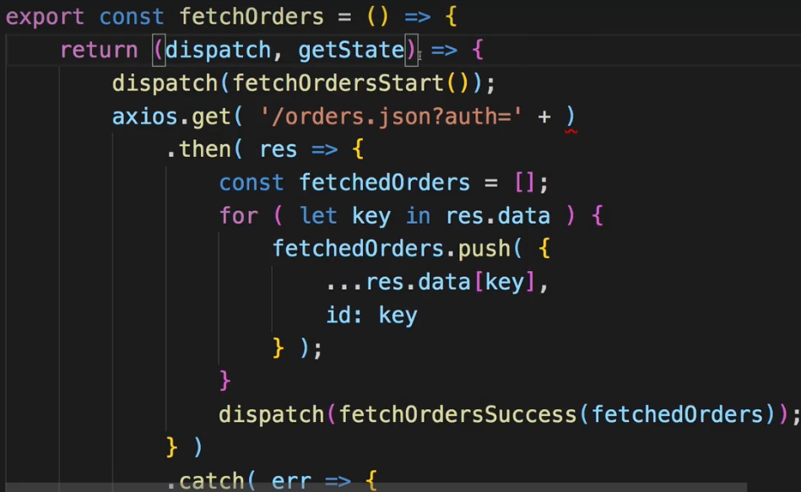  
=> I don’t recommend using that a lot and I don’t want to use it here, though I see that this could be a case where it makes sense to get this information which doesn’t really matter to your view, right in the ACTION CREATOR.  
=> Still I want to get it in the place where we dispatch() the fetchOrders ACTION and then simply pass it as an ARGUMENT to this ACTION CREATOR:  
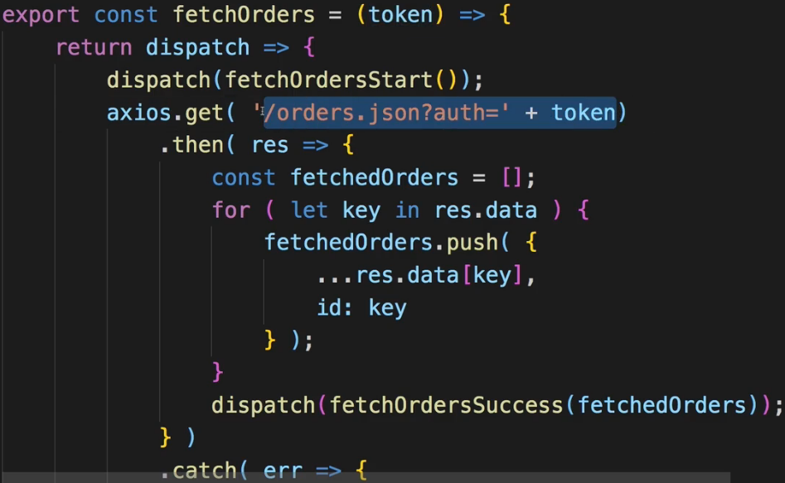  
=> Now the missing piece is to make sure that we receive the TOKEN here when dispatching fetchOrders.  
=> fetchOrders is of course dispatched in Orders.js container.  
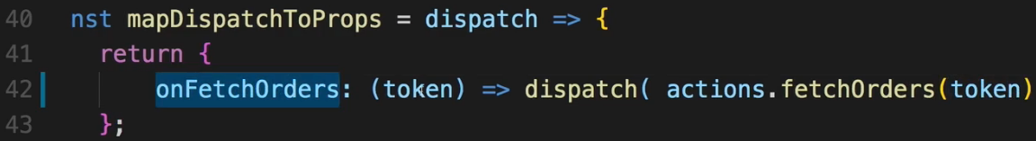  
=> And finally we need to get the TOKEN in the place where we call onFetchOrders.  
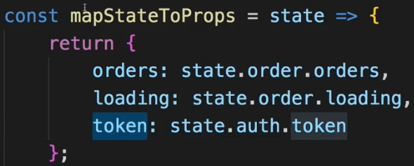  
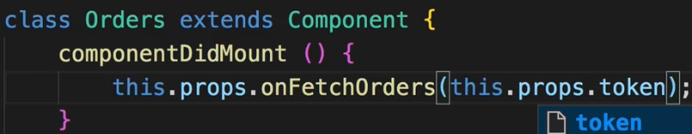  
* This is only 1 way of doing it, the alternative would’ve been to use getState in the order.js ACTION CREATOR.  
* Now when we log in and go to orders, we now successfully load the orders here again, without any error, because now we successfully sent the Request with the TOKEN attached.  
* And you can actually see this if you open the Network tab in the Chrome Devtools, there if we go back to orders again, we can see the Request being sent where the TOKEN is attached:  
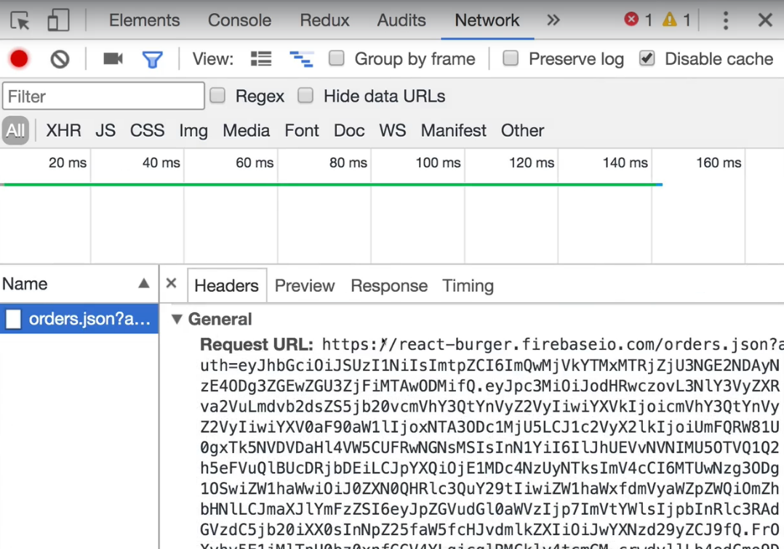  
=> This is the very long URL because the TOKEN is part of the URL.  
=> That is how we have to authenticate and how we can send our TOKEN to the Backend.  
* Of course the same is relevant when we make an order, in order.js ACTION CREATORs file in purchaseBurger ACTION CREATOR.  
=> There we also need to get that TOKEN as an ARGUMENT.  
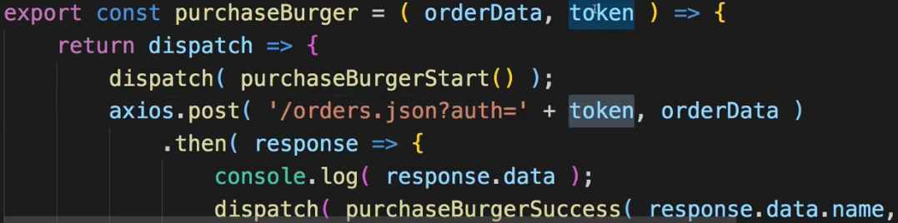  
=> And for that we of course have to make sure that we do receive the TOKEN here too.  
=> So we have to go to the place where we dispatch() purchaseBurger.  
* In ContactData.js:  
* There we have our method for making an order - the orderHandler where we have `this.props.onOrderBurger(order)` which in the end dispatches this ACTION CREATOR.  
=> We need to add the TOKEN here:   
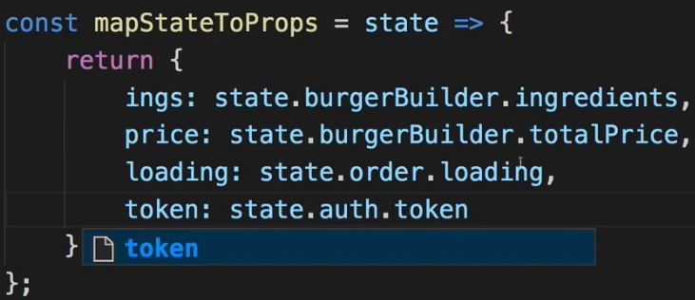  
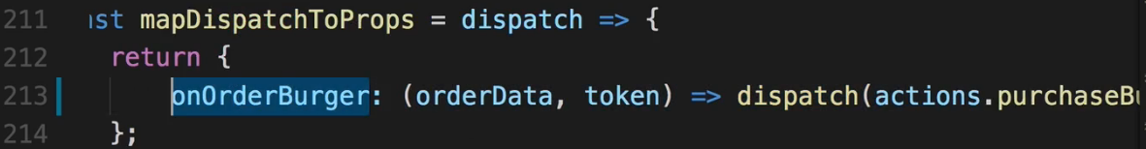  
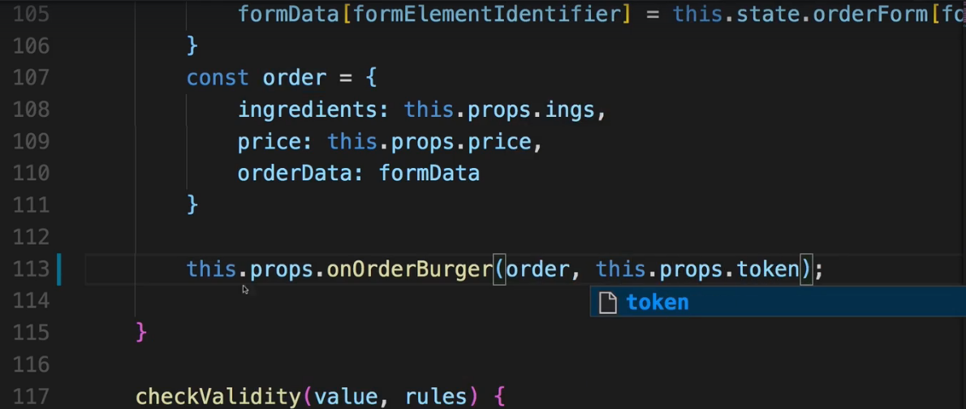  
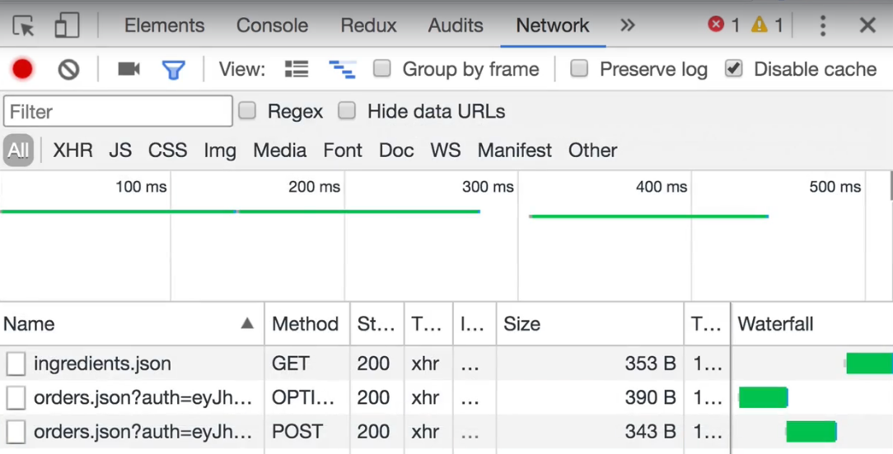  
=> Don’t be confused by this OPTIONS Request - which Chrome always sends if you’re sending a POST Request.  
* So this is now working, no we’re using that TOKEN to reach protected resources.  
* Of course it’s not the greatest User Experience to just visit a page and then fail - it would be better if we couldn’t visit pages where we need to be authenticated in the first place. Of course it’d also be better if the UI showed us if we are authenticated and it would be best if we could also log the user in if there theoretically still is a valid TOKEN so that we don’t lose our authentication state whenever we reload the application.   
* These are all things we’re going to tackle over the next lectures.  
**Updating the UI Depending on Auth State**  
* In the navigation having something instead of Authenticate when we sign in would be nice and it’s very easy to implement.  
* In NavigationItems component:  
* For that we need to check our log-in state in NavigationItems.  
* NavigationItems of course is a presentational component so we can’t connect this to Redux.  
* Well we could simply turn it into a class-based one and then use connect() on this component - you can do that, I wouldn’t recommend it though - this breaks the idea of having a few container components which are connected to the STORE and having a lot of dumb components which don’t know about the STORE. So I wouldn’t recommend using that approach.  
=> **A better approach would be to pick a fitting container which actually loads NavigationItems**.  
=> And here it’s not in the `containers` folder but in the `hoc` `Layout` folder in Layout.js simply because we use it to wrap other components.  
=> There we have the Toolbar and the SideDrawer which are of course the components which use NavigationItems in the end:  
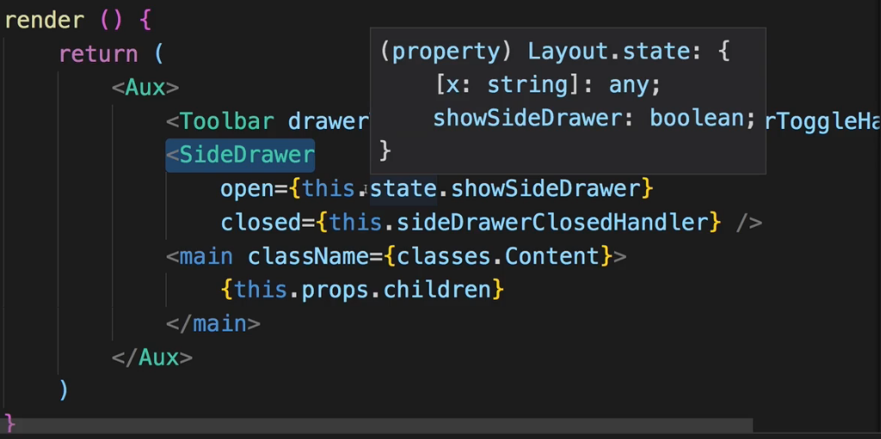  
=> So it would make sense to connect the Layout.js to our STORE so that we can pass the `auth` information down to Toolbar and SideDrawer which then in turn could pass it to NavigationItems.  
  
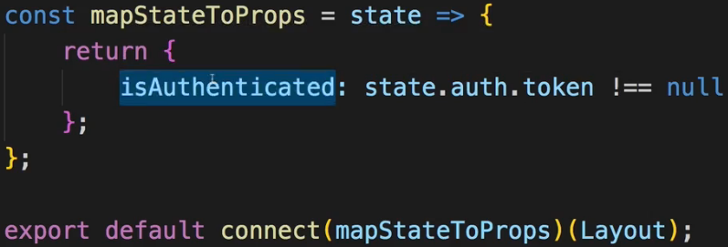  
* Now we can use it as a prop.  
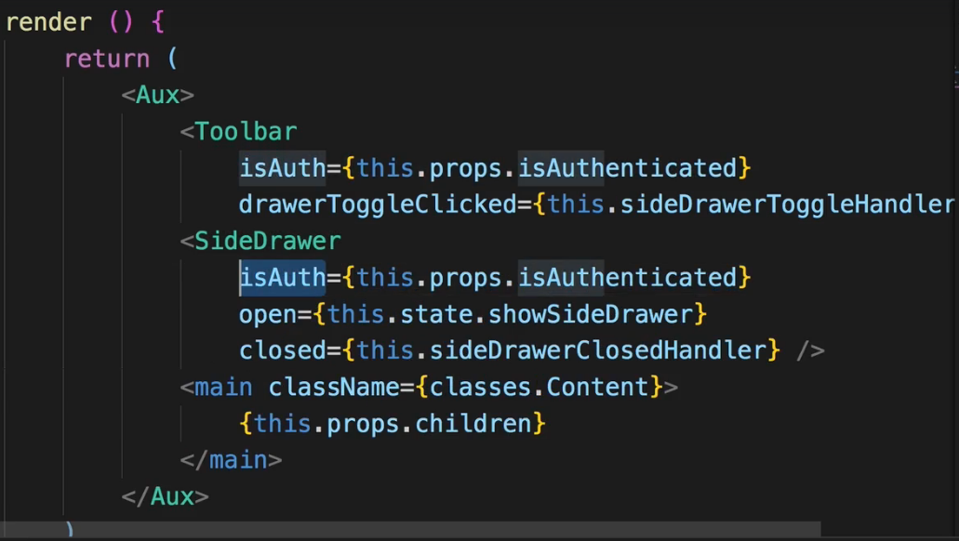

* Now of course I need to edit these 2 components to be able to use that new prop.  
* In Toolbar.js:  
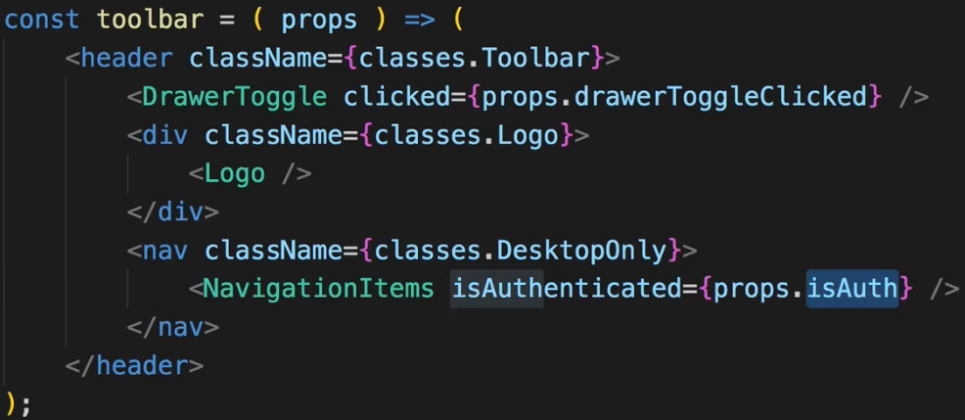  
* And pass it to NavigationItems.  
* Now I’m switching up these names just to make sure we’re not confusing what’s coming in and what we’re passing on.  
* The same for the SideDrawer.js:  
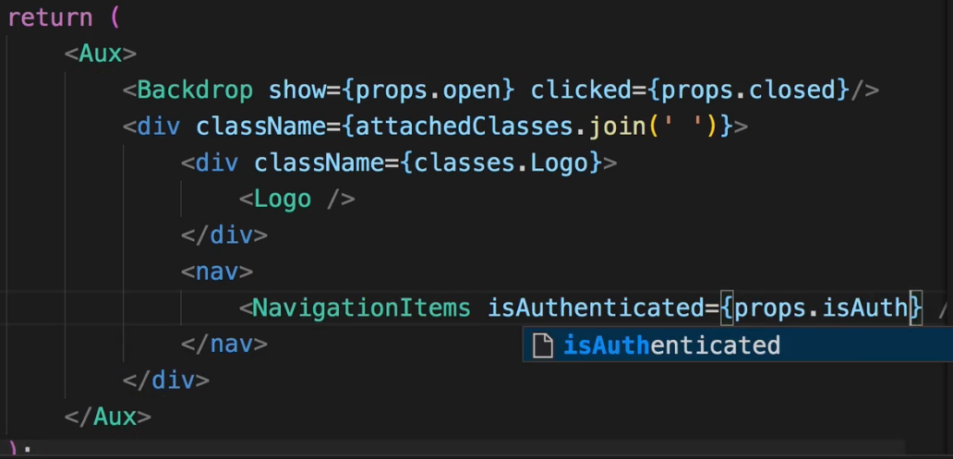  
* Now in NavigationItems.js:  
* I now that I receive this `isAuthenticated` prop which is true or false.  
* We use an inline ternary operator:  
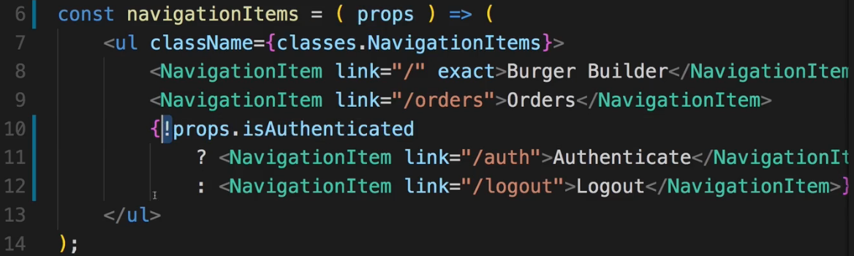  
* Next let’s make sure that when we click “Logout”, we actually do something, this route doesn’t exist yet.  
**Adding a Logout Link**  
* In the last lecture we made sure that we updated the UI depending on our authentication state and of course the same logic we used there can be used anywhere in your application if you need to change something depending on your auth state. We’ll also do that in one of the next lectures.  
* For now I want to make sure that the “/logout” link works.  
=> Upon a logout I want to clear my TOKEN and we do have an ACTION for that in auth.js there we have that logout ACTION CREATOR.   
=> **So I want to dispatch() that**.   
=> **And I then want to Redirect**.   
=> For example if we click “Logout”, I always want to Redirect back to the starting page so that if we were on orders, we’re not staying there because we’re not authenticated anymore.  
* Now there are different ways you can achieve this.  
=> **1 possibility would be to go to your NavigationItems here and make sure that you create a separate kind of NavigationItem which isn’t a link but actually a button. And then you could register some `action` prop which in the end is a link to a method you want to call/dispatch**. That would be a way to handle this situation.   
=> **I want to show you this way with linking to a page which then just Redirects you and logs you out**.  
* In `containers` in `Auth` folder I’ll add a new sub-folder `Logout` and there Logout.js file.  
=> This will be a class-based component.  
=> Here I want to do 2 things:  
 => **Dispatch an ACTION**.  
 => **Redirect**.  
* To be able to access the logout ACTION, I need to export it in the index.js in `actions`:  
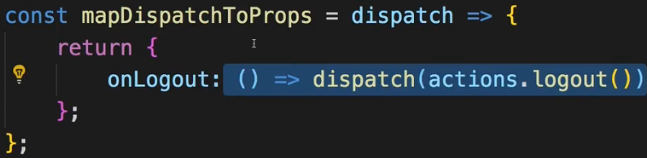 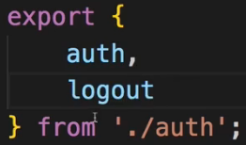  
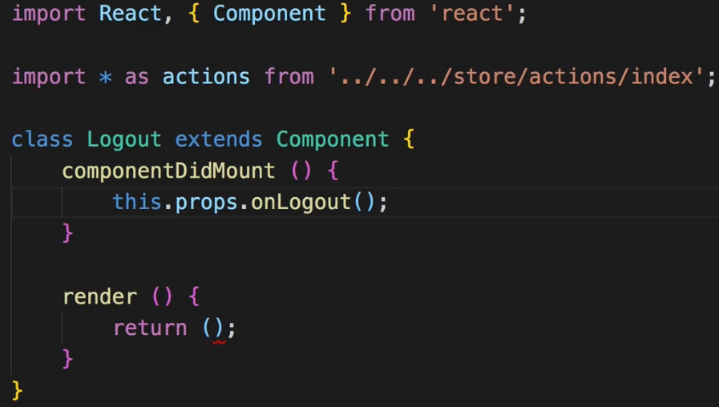  
* Now I also want to Redirect.  
* We have 2 different ways of doing that.  
=> **1 would be to forward the props of this component which will be loaded via the router so therefore we could forward `this.props.history` and there we would have the .push() method**.  
=> Now what I want to do instead is: I want to Redirect declaratively.  
* I’ll import the Redirect component from react-router-dom, that’s a very elegant way of Redirecting.  
  
* And then the only thing I return as part of this component is that Redirect component here.  
=> Which means whenever this container is loaded, it just Redirects me. Of course, I very easy way of Redirecting the user.  
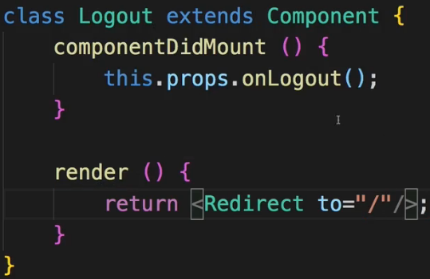  
* With that the only thing that’s left to do is make sure that the Logout.js container gets loaded for “/logout”, I do this in my App.js file on the root level where I have all my Route-s.  
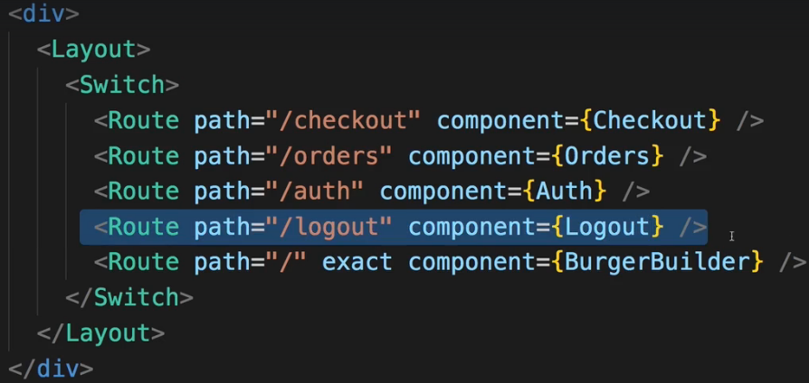  
* Let’s not forget to import and use connect() in Logout.js and wrap our logout function with the function that the connect() returns to be precise.  
  
* Now with that implemented, I wanna work more on the UI.  
* I want to make sure we don’t even see the “Orders” button when not authenticated.  
* And I want to make sure that when we build a burger, that this is available when we’re not authenticated but that the “ORDER NOW” button actually is a “SIGN UP TO ORDER” or something like this button when we’re not authenticated.  
**Forwarding Unauthenticated Users**  
* Let’s work on the NavigationItems first.  
* Not to see the “Orders” when we’re not authenticated - we can do with the ternary operator again.  
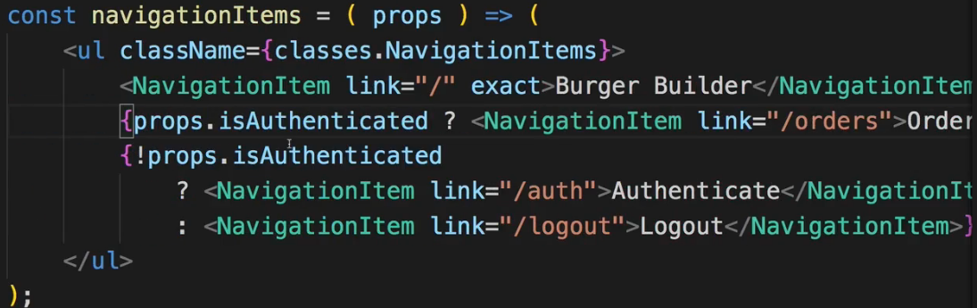  
=> This is a quick and easy and correct way of ensuring we never see “Orders” if not authenticated.  
* Another thing - when we did log in successfully, I want to Redirect away from the authentication form here.  
* In Auth.js container:  
* Here we are already connected to the STORE so we can just add:  
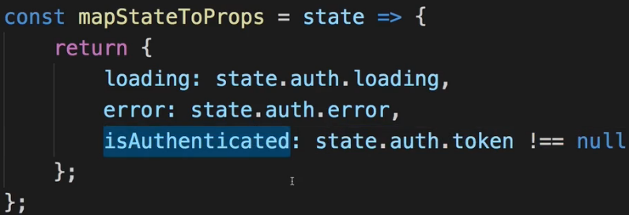  
* And then again I’ll use that Redirect component from react-router-dom to redirect the user if he is authenticated, so you see that’s a common pattern because it’s so powerful and easy.  
* We add a simple IF check in the render() before we return JSX.  
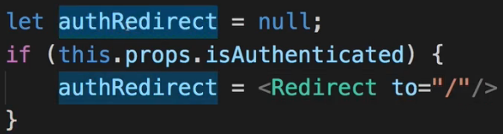  
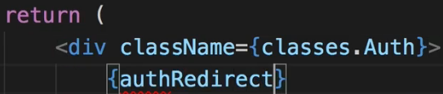  
=> With this simple trick, we can ensure that when we log in and click “SUBMIT”, we are redirected.  
* Let’s now ensure that when the Burger Builder is used, that we can use it even if we’re not authenticated. But that once I start building one and I click “ORDER NOW”, I don’t reach a page where I can’t do anything anyways, but instead that it says “SIGN UP TO CONTINUE” so that you have to sign-up to continue checking out the burger.  
* To do that, I will go to my burgerBuilder container of course:  
=> This is where I include the BuildControls, this is what’s holding the “ORDER NOW” button. And the BuildControls need to know whether I’m authenticated or not.  
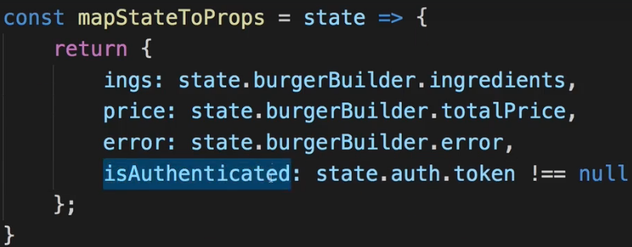  
=> Now pass it to BuildControls as a prop.  
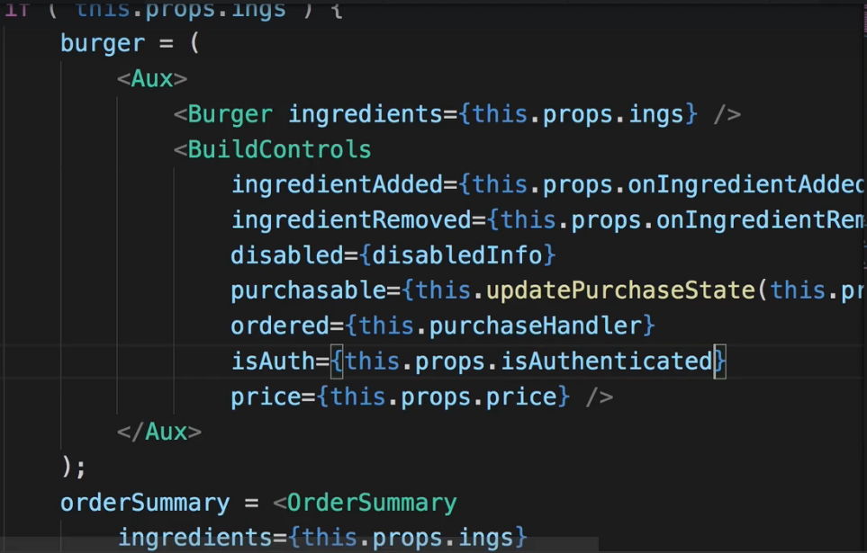  
* In BuildControls component:  
=> **Now the idea is that in the end we do just what we do in the Modal when we continue or to be precise what we therefore do in the OrderSummary on continuing - that purchaseContinueHandler is executed there and there we simply .push() to “/checkout” => so that we do .push() to “/checkout” once the user signed up - if he signed up through our redirection from the BurgerBuilder**.   
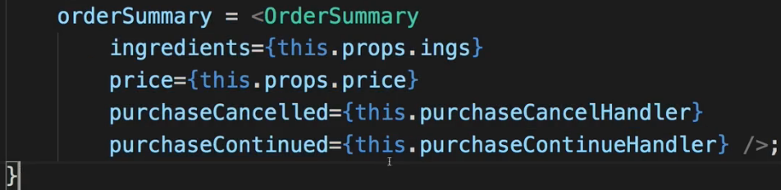  
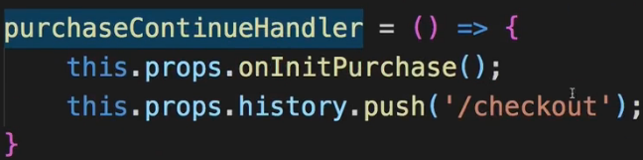  
=> For that we first of all need that Redirection so back to the BuildControls:  
=> It’s this button we want to work on.  
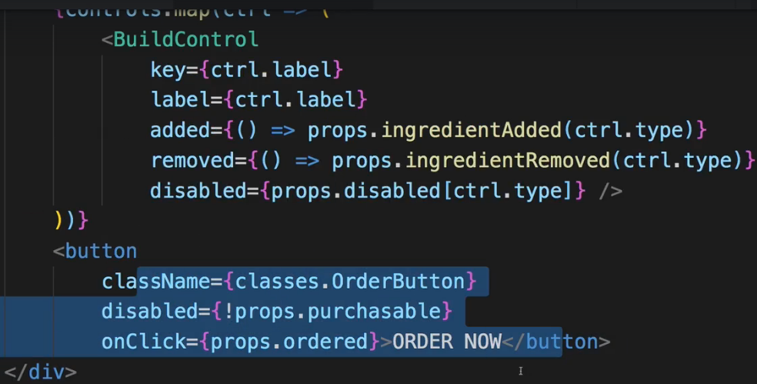  
=> This button here should behave differently if we’re not authenticated.  
=> I’ll handle most of that logic in the BurgerBuilder.js container though, here I only want to change the caption:  
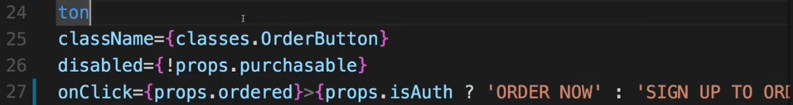  
* Now the button does change between “ORDER NOW” and “SIGN UP TO ORDER”.  
=> Now we need to make sure that this button does the right thing.  
* Keep in mind: when we click the button, we simply execute the method which is sent to this component on the `ordered` prop.  
* In BurgerBuillder.js:  
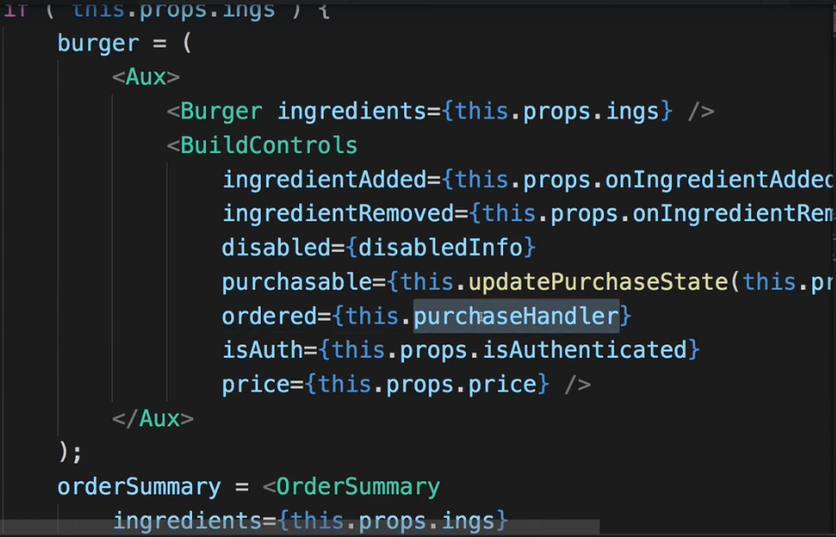  
=> We see that the `ordered` prop is bound to `this.purchaseHandler`.  
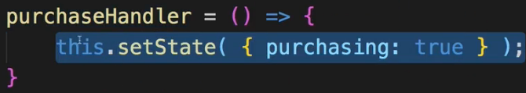  
=> The purchaseHandler shows us the Modal by setting `purchasing` to true in this container.  
=> Now I only want to do that if we’re authenticated, otherwise I want to Redirect to my “Authenticate” page.  
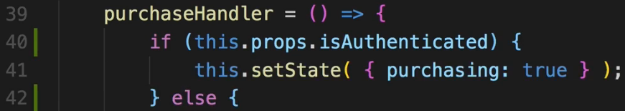  
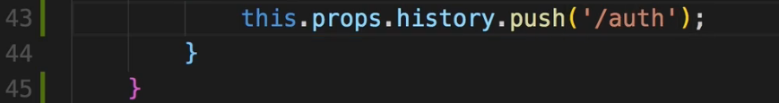  
=> I want to use my `history` prop - this is coming from React Router if you remember, to push the user to the “/auth” Authentication page so that he has a chance of signin up.  
* Now if we click the “SIGN IN TO ORDER” button, it redirects us here to the sign up page.  
* Of course the issue that we have is that if we now sign in, we’ll simply be redirected back to Burger Builder and our currently built burger will be lost.  
=> Would be better to be redirected directly to the checkout page and there still have our burger - that would be the case because the burger ingredients are stored in the Redux STORE and if we don’t go back to Burger Builder, this won’t be reset, but of course that redirection is the issue - because we only want to redirect in the scenario in which the user just got into the app and clicked Authenticate, we don’t want to redirect them to checkout because no burger was built yet, there won’t be any ingredients to check out.  
* Let’s take a look at how we solve this problem, in the next lecture  
**Redirecting the User to the Checkout Page**  
* So we want to make sure that when we build a burger and are redirected to the signup page because we weren’t authenticated, that we are then redirected to the checkout page from the authenticate page so that we can continue with the burger checkout.  
* This is actually not that difficult.  
* There are multiple ways of doing that.  
=> 1 way would be to simply store some information in your Redux STORE. Store the information if we’re currently buillding a burger. And reset that whenever the user visits the Burger Builder page.  
* We’re kind of storing this already - in our burgerBuilder REDUCER whenever SET_INGREDIENTS caught, that means that the user visited the Burger Builder, SET_INGREDIENTS of course resets all ingredients by setting them to the reloaded state and therefore it is easy to add a new property to our burgerBuilder STORE which would be something like `building: false`. Now we can set this to true whenever we add/remove an ingredient and false in SET_INGREDIENTS.  
=> Let’s do that.  
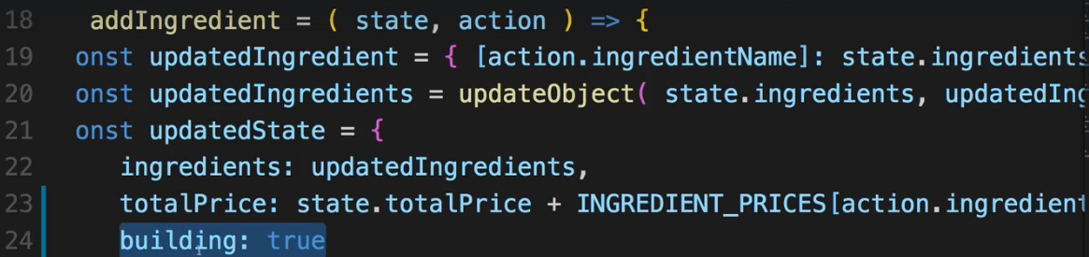  
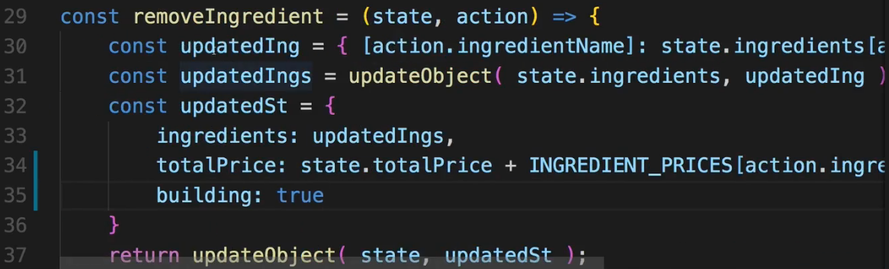  
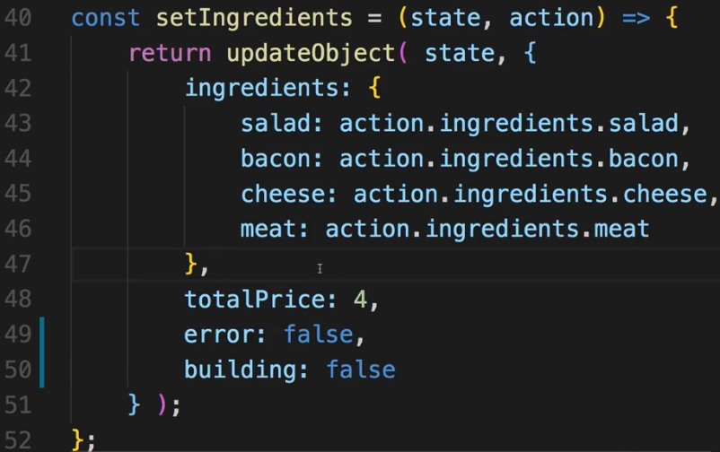  
* Now in Auth.js:  
* There we should have 2 Redirects - 1 to “/” and 1 to “/checkout”.  
* Now a more dynamic approach if you need to support different URLs would be to store the URL in your Redux STORE so that path we want to go to so that we can dynamically replace it here, OR to pass that path as query params through routing.  
* Let’s do that half measure and store the path in the Redux STORE even though in our app we only have 1 path.  
* In auth.js REDUCER:  
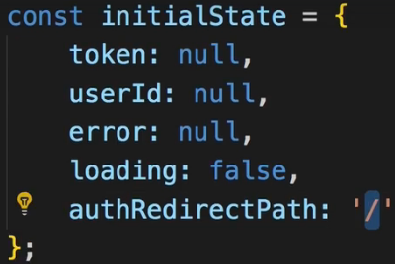  
* In actionTypes and auth.js ACTION CREATORs file.  
  
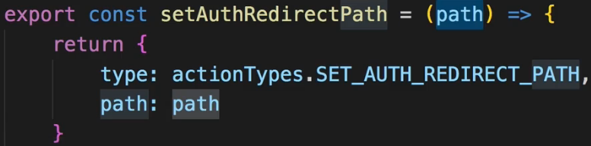  
* In auth.js REDUCER:  
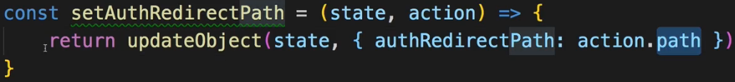  
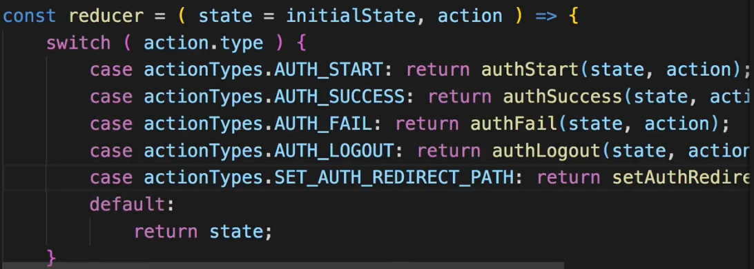  
* In index.js ACTION CREATORs bundle file:  
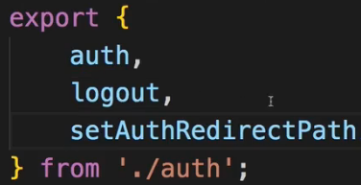  
* Now where do we need to change the path?  
* Obviously in the BurgerBuilder container - here we are redirecting to “/auth” in purchaseHandler and before I do this, I want to change the redirect path away from that “/auth” page.  
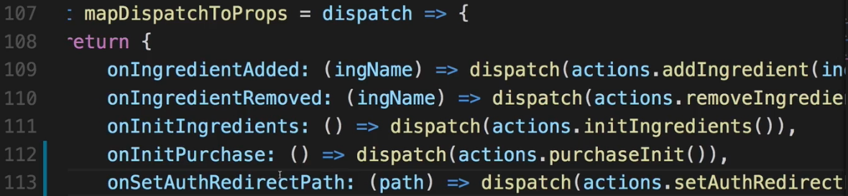  
* And I want to do this right before we actually redirect to the “/auth” page, we could also do it thereafter though.  
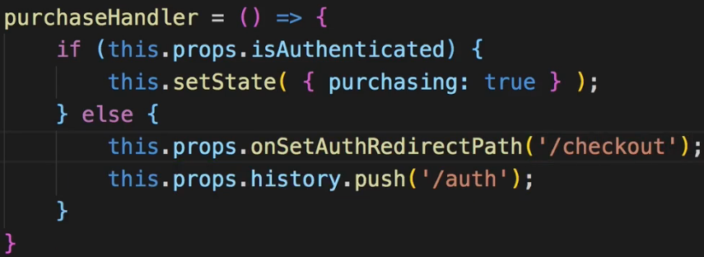  
* With that we got our redirect path set up.  
* We also want to set the redirect path to “/” if the user clicked on the authenticate button in our navigation though and this is something we can do in the Auth.js container itself.  
* Now we do reach this Auth.js container by pushing it so by loading it as a route, and therefore if we dispatch() the onSetAuthRedirectPath() in there, this will always be set whenever we go to the “/auth” page.  
* However, keep in mind that we have 1 additional piece of information in our STORE - in the burgerBuilder REDUCER, we have that `building` information. That information is very useful to us of course, we can use it in the Auth.js container to change the redirect path back if we think that the user is actually not building a burger anymore.  
* In Auth.js:  
* And there in componentDidMount() I want to dispatch() this ACTION too if we’re not building a burger, otherwise this path is probably set up correctly.  
+++ The state slice name is based on the property name in combineReducers in index.js.  
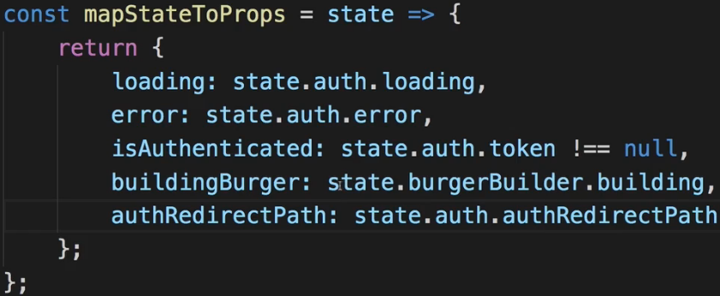  
* Now in mapDispatchToProps we could receive the `path` as an ARGUMENT to this function here and pass it on, or we just hard-code “/” in here because if I call this ACTION from within that component, I always want to reset it back to its basic form.  
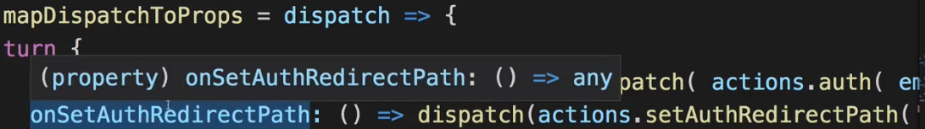’/’  
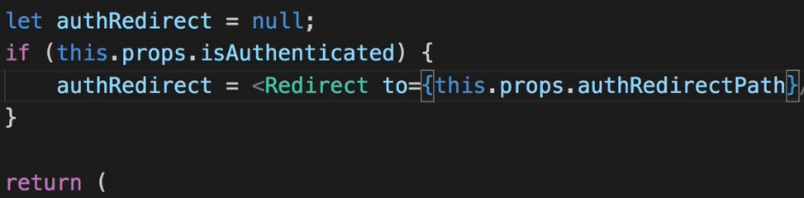  
* Now I have to make sure that I actually reset the path if we reach this page while not building a burger. And that is what we do in componentDidMount().  
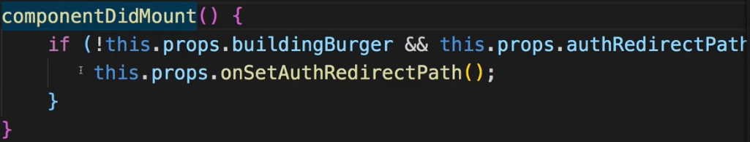  
=> That would mean we’re trying to redirect to “/checkout” even though we’re not building a burger.  
**Persistent Auth State with localStorage**  
* If we are logged in and we reload the page, the login state is lost, the reason for this is that when we refresh the page, we download the SPA again, we download the JavaScript again, it gets executed again, it’s a totally new application when we look at it like this. Therefore our state stored in Redux which is in the end just stored in JavaScript, is of course lost.  
* So we need to persist our login state across our session. And this requires a browser API we can use - **localStorage**.  
* In auth.js ACTION CREATOR:  
* Here on success we pass on the TOKEN. And it would make sense to also store that TOKEN in our browser localStorage then.  
* The localStorage API is baked into the browser so we can easily use it.  
* We can either use it here in `auth` ACTION CREATOR, or in `authSuccess` before we dispatch() an ACTION, there we could run some additional code, we get the TOKEN here but I don’t want to work with just the TOKEN, I also want to work with the `expiresIn` expiration time.   
=> So I’ll set the TOKEN here in `auth` ACTION CREATOR.  
* **localStorage.setItem(key, item)**  
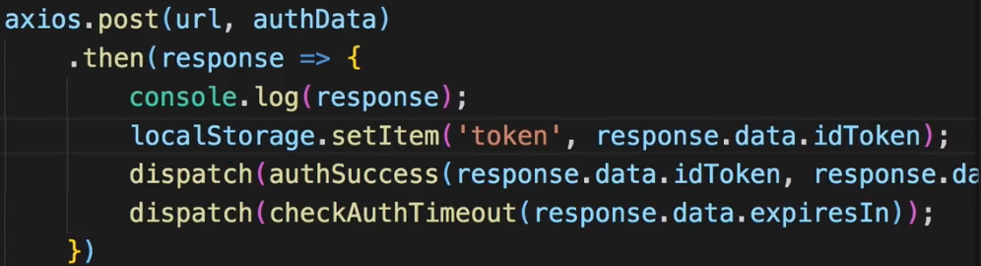  
* Now that’s nice but the TOKEN alone won’t be that useful if we fetch it in the future, we also need to know when it expires. Now I could store the expiresIn but that’s just the amount of seconds until it’s invalid, that won’t tell us much the next time we fetch this from localStorage because the number of course won’t update. So instead, we should store the expiration date. * 1000 because JavaScript time works in miliseconds.  
* new Date().getTime() gives us the current time of the day, + response.data.expiresIn * 1000. And now this gives us the expiration time but to turn this into a date object again, we have to wrap all of that with new Date(). So new Date() without arguments gives us the current date and new Date() with arguments gives us a date with the date we pass as an argument so here this argument will be the current date + expiresIn in seconds.  
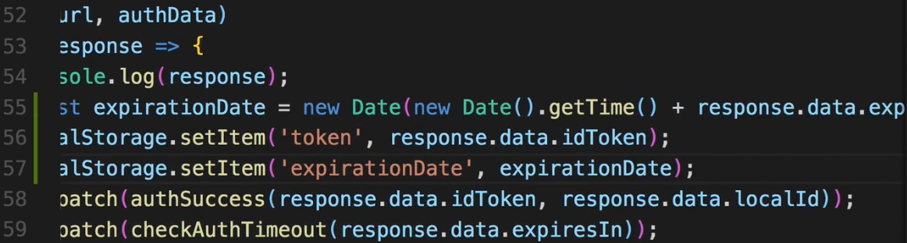  
* We can inspect our localStorage in the Chrome Devtools by going to the Application tab, there you’ll find some storage information and you can click on Local Storage and expand it and click on your domain.  
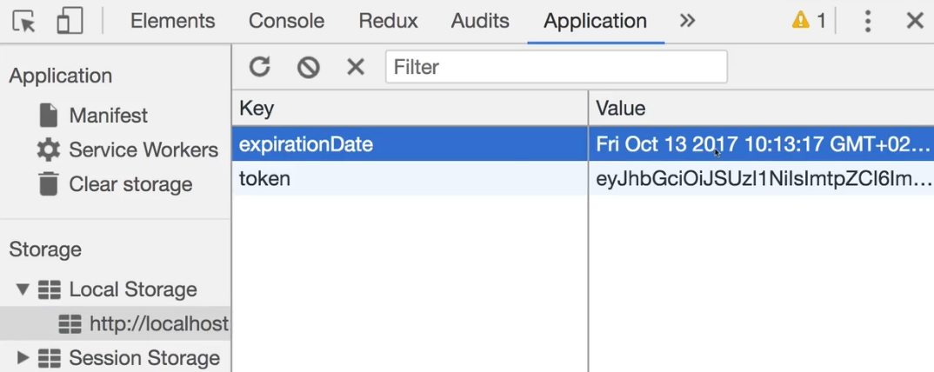  
* Now we can take advantage of these 2 fields to check them whenever our application loads to log the user in if we got the TOKEN and if it’s still valid so if we haven’t passed the expirationDate yet. Otherwise we want to clean this up. And we want to clean this up with the `logout` dispatch ACTION.  
* In auth.js ACTION CREATOR file:  
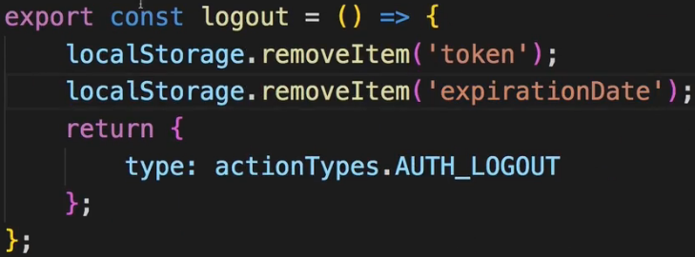  
* So now let’s fetch the TOKEN when we log in.  
* Where can we check this?   
=> Well we should check it when the application loads so for example in App.js, this is the root component of our app and it’s always loaded, no matter which route we visit. So therefore this makes for a great app to check our authentication status.  
=> For checking this, we’ll need a new ACTION.  
* In auth.js ACTION CREATORs file:  
* And there I essentially want to dispatch() `authSuccess` whenever we are logged in, but also dispatch() `checkAuthTimeout` and pass the expiration in to still have that functionality going.  
  
=> I’ll return a function here so that I can dispatch multiple ACTIONs - I won’t run Asynchronous code, but I still want to dispatch multiple ACTIONs from within this ACTION.  
* If the TOKEN is null, I’ll call the `logout` ACTION but that also shouldn’t be required, still let’s do it.  
* I’ll first of all wrap this expirationDate with new Date() because what we retrieve from localStorage will be a string but with new Date() we can convert it into a Date object.  
* I need the userId for `authSuccess` - for that I’ll need to fetch it, of course we could also simply store it in localStorage and that wouldn’t be wrong. You can, however, also send a Request to the Firebase Auth API to get it from there.   
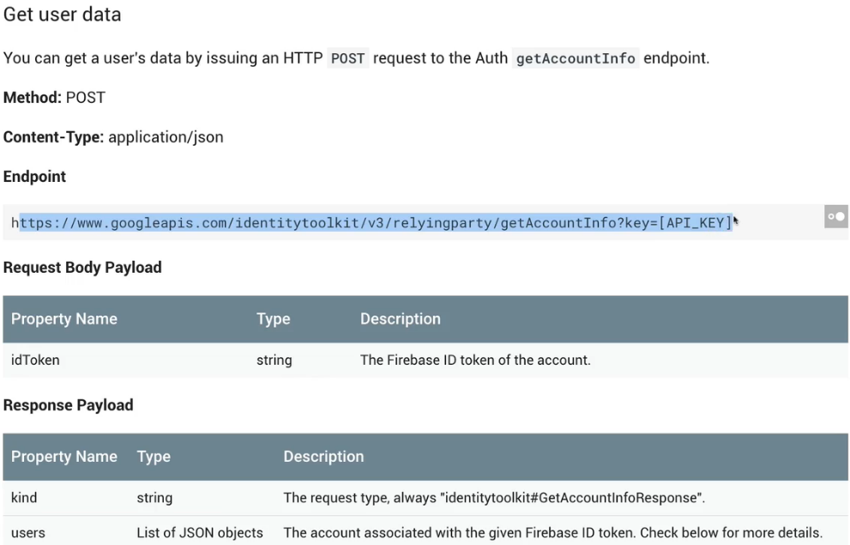  
=> So this would be a way to get the user data, in the response you would have a users object which actually is an array and in the first element of the array you’d have your user and localId would be the user ID.  
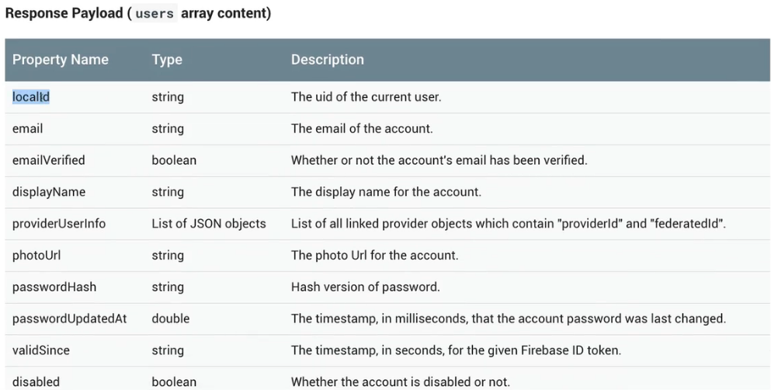  
* So this is how you could fetch it from the server.  
* **I, however, will simply store it in localStorage because it’s a bit easier here**.  
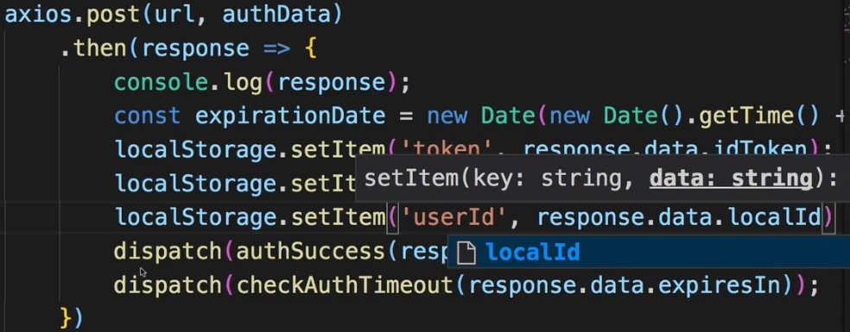 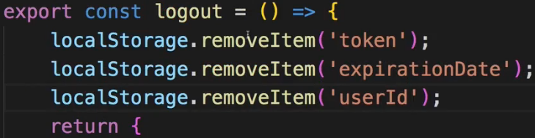  
* And with that we can fetch the user ID if we are logged in.  
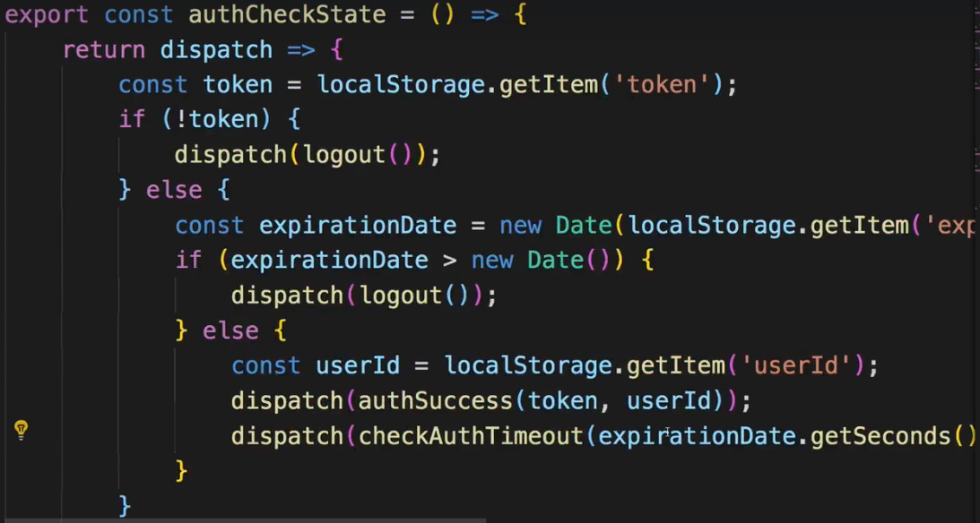  
* Now for `checkAuthTimeout` we need the time in seconds, expirationDate is the time when we are logged out, not the amount of seconds.  
=> What we can do though is:   
we can simply pass `**expirationDate.getSeconds() - new Date().getSeconds()**`.  
* So with that we’re dispatching everything here in `authCheckState` so this is a pure UTILITY ACTION CREATOR which dispatches a couple of other ACTIONs depending on our current state and with that we can dispatch() `authCheckState` to successfully automatically log the user in if we have a valid TOKEN.  
* In index.js ACTION CREATOR bundling file:  
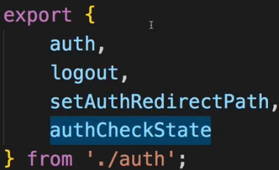  
* In App.js container:  
* We need to import connect() to be able to dispatch() anything from this container.  
  
  
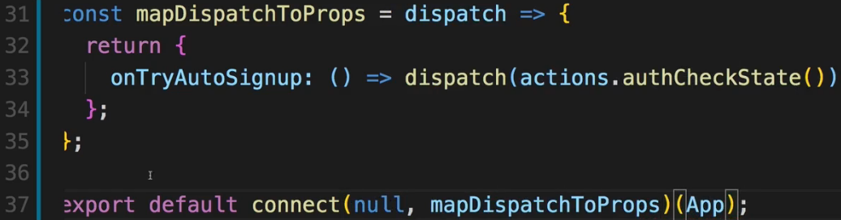  
=> Now let’s execute this for example in componentDidMount().  
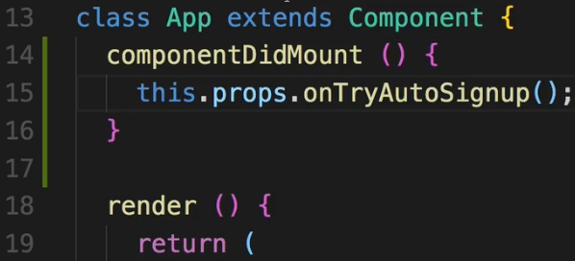  
* **We have a mistake in the `expirationDate > new Date()` logic, it should be the other way around**.  
**Fixing Connect + Routing Errors**  
* The error we’re facing here has to do with the fact that we’re wrapping our App.js container with connect().   
=> That simply breaks our React Router.  
=> We can easily fix that though - we need to import the withRouter HOC.  
  
=> And if you got an error like this, which is always related to connect() wrapping your component which you also want to load with Routing and therefore this component doesn’t receive your ROUTE PROPS, you can simply wrap connect() with withRouter().  
  
* And now with that tiny change, withRouter will enforce your PROPS being passed down to your App.js component still and therefore the React Router is back on the page and we’ll know what’s getting loaded.  
* So now the routing is working and we can go to Authenticate and test what we implemented last.  
* It’s not working as intended - to debug that, let’s go to Sources, and there into our folder and let’s dive into STORE > actions > auth.js file. So now we can place a breakpoint here in our authCheckState function.   
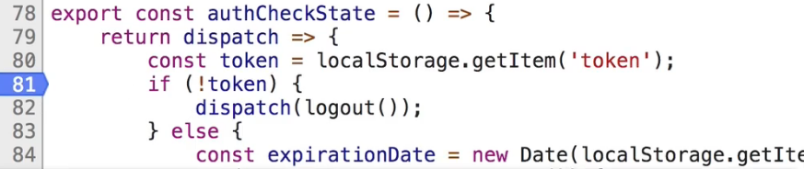  
=> Now let’s go to Authenticate and log in again and then reload the page. If we aim at the TOKEN in the code, we see we do fetch it successfully.  
* Let’s now walk through that using “Step over next function call”, we make it into the else block.  
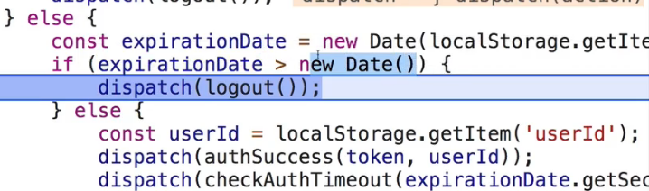  
=> Here’s our mistake. I don’t want to logout in this case because that’s exactly the case when the TOKEN is valid.  
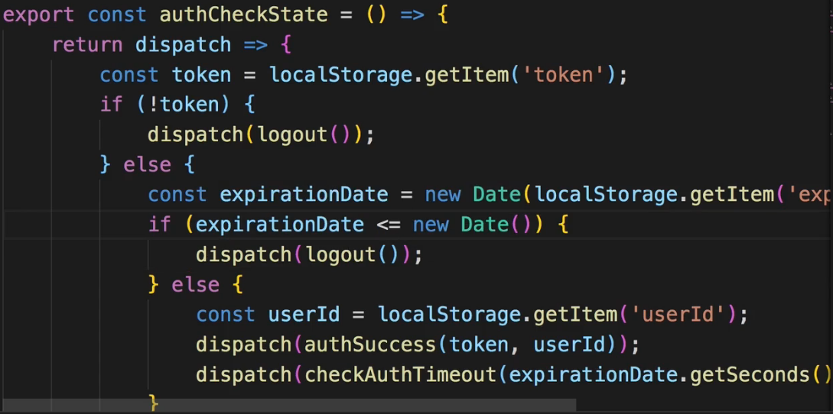  
* If we reload now, we have AUTH_SUCCESS but still followed by AUTH_LOGOUT.  
* So let’s again debug this.  
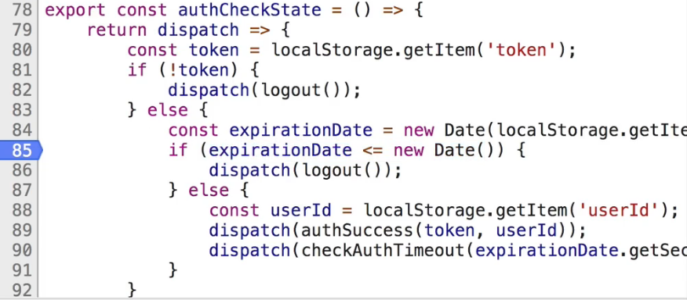  
=> It might be related to our `checkAuthTimeout` where we also dispatch() `logout`.  
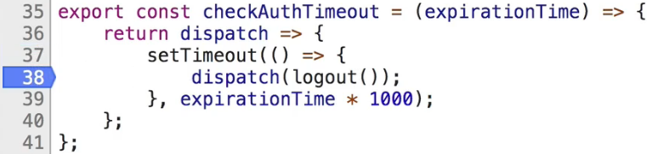  
=> Let’s place a breakpoint here to see if this gets triggered.  
=> And indeed we now reach the second one in setTimeout(), this shouldn’t fire though.  
=> The issue probably is the expirationTime we set up.  
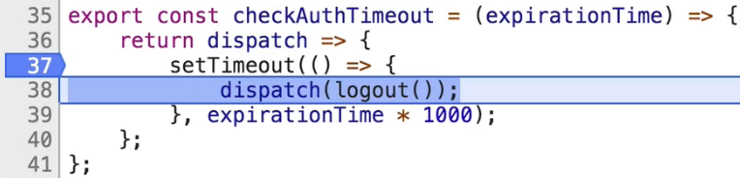  
=> Let’s set a breakpoint here to find out which value is set as expirationTime there because that has to be the issue.  
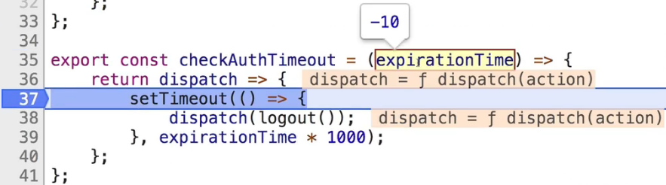  
=> It’s -10. And it makes sense that this is -10. We got a couple of errors here.  
=> So what’s our problem?  
=> To the `checkAuthTimeout` I’m passing the difference between the future date and today:  
  
=> **Now the issue is that I use .getSeconds(), I wanted to use .getTime() here. That’s the time in miliseconds, that’s the big number I wanted to use**:  
  
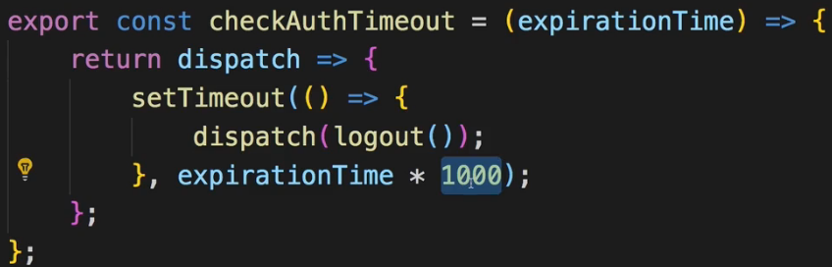  
=> Since we * 1000 here, the number would be too big so we have to / 1000.  
  
* Now let’s see if that works.  
* Now we are still logged in and we still have our localStorage filled with data.  
**Ensuring App Security**  
* Now let’s talk about security a little bit.  
* Let me log in again.  
* We manage our `auth` state here with the TOKEN and we automatically log the user in if we have a valid TOKEN.  
* That TOKEN is only valid for 60 minutes though. That is for security reasons because if the TOKEN gets stolen, anyone can access your data of course.   
* Keep in mind though - it’s stored in your application in localStorage, localStorage can be accessed with Cross-Site Scripting Attacks and those are prevented by React. You can’t output insecure code by default. So you got a lot of protection from that side. So your data in localStorage should be safe. Additional safety net then is again that the TOKEN expires after 1 hour.  
* Now Firebase would give you theoretically that REFRESH TOKEN in the response. The REFRESH TOKEN doesn’t expire, you could store that to localStorage and then there is a specific Endpoint on the Firebase Auth REST API where you can exchange a REFRESH TOKEN for an ID TOKEN. You just send your REFRESH TOKEN to this API Endpoint and you get back a new ID TOKEN.  
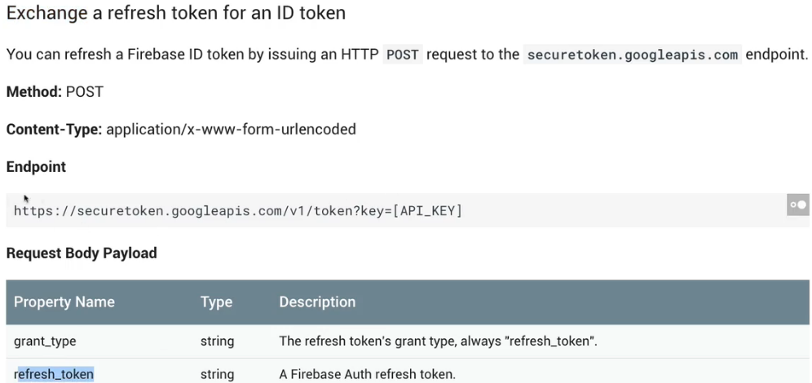  
* Theoretically that’s a cool pattern, you can always do that with every HTTP Request you send - with every Request you send, you send an additional one where you exchange your REFRESH TOKEN for a new ID TOKEN, even if the ID TOKEN hasn’t expired yet, so that you always get new ID TOKENs.  
* And you could also get a new one when the user is automatically signed-in with the functionality we added over the last lectures.  
* I opted to not use that here.  
* It’s also safe because we can store the REFRESH TOKEN in localStorage and as I mentioned this is only accessible with Cross-Site Scripting Attacks.  
* Still, having a TOKEN which never expires and which you can exchange for a TOKEN which gives you access to everything, could lead to security issues, or at least you should be very careful about protecting it if you are using the REFRESH TOKEN.  
* That’s just something I wanted to add - you can enhance the user experience by using the REFRESH TOKEN, you can essentially make sure the user is never logged out because as the REFRESH TOKEN never expires, you can refresh the main TOKEN even after a week, just check for the TOKEN being valid, if it isn’t, take the REFRESH TOKEN and get a new one.   
* But due to that security thing I opted to not use it and I wanted to bring this to your attention.  
**Guarding Routes**  
* There are 2 more things I want to do:   
**=> 1 =>** I also want to store the user ID in any order I place, so that on the Backend in the orders we not only have ingredients but in the orderData or as an extra field, we also store the user ID of the user who made that order. That’s another nice improvement to our app and we can then also make sure we only fetch orders by that user.  
**=> 2 =>** The other thing I want to do is: I also want to make sure that you can only visit the orders page and the checkout page - even though we do redirect there if you are not building a burger - but that you can visit both only if you are logged in. What I also want to do is that if you’re logged out, if you visit “/orders”, you can’t go there instead of getting a 401 error. We already removed the navigation item but manually visit it in URL works.  
* **Let’s start with GUARDING the “/orders” page**. So that unauthenticated users can’t visit it.  
* It’s super easy due to the way React Router works.  
* In App.js container, where we have all our routes:  
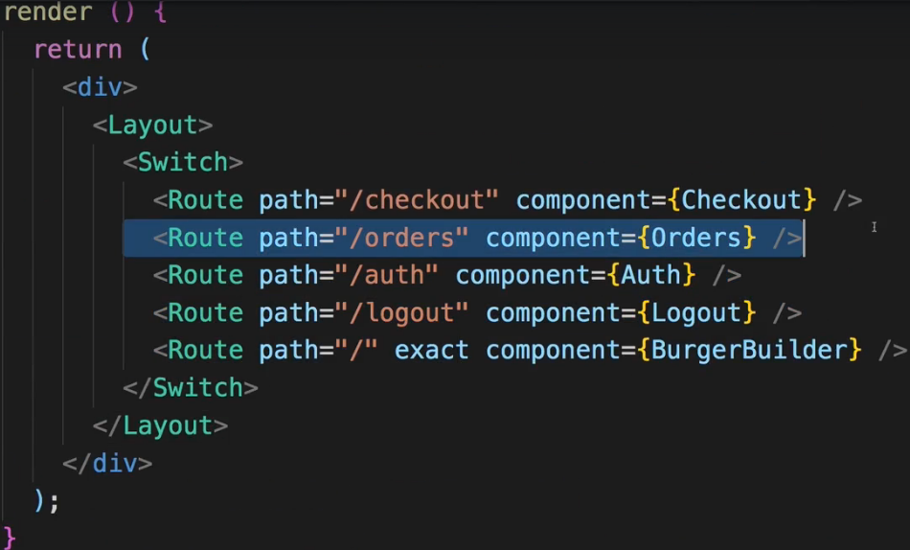  
=> If we don’t render this Route component, we got no way of going there, we just can’t reach it because the React Router isn’t aware of it and will never load it.  
=> For that reason let’s add `mapStateToProps` to find out if we are authenticated.  
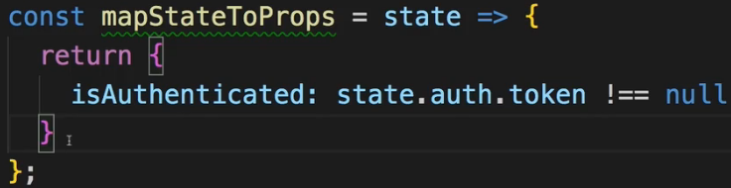  
  
* Now the first `routes` will be the unauthenticated routes:  
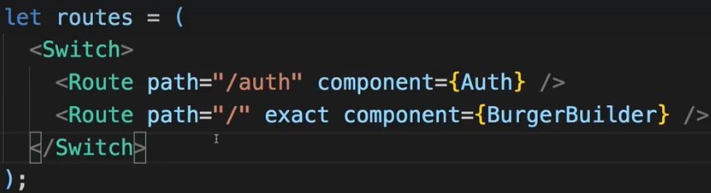  
* These are available for authenticated users:  
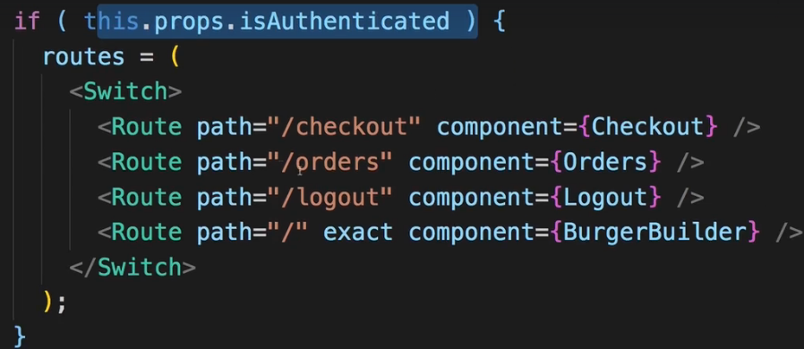  
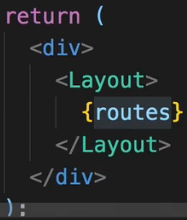  
* With that we have GUARDS in place.  
* We now can’t reach the “/orders” page if we’re not authenticated, not even manually in URL. You see an empty page.  
=> Now to not just see an empty page, we can of course make sure that we Redirect the user.  
  
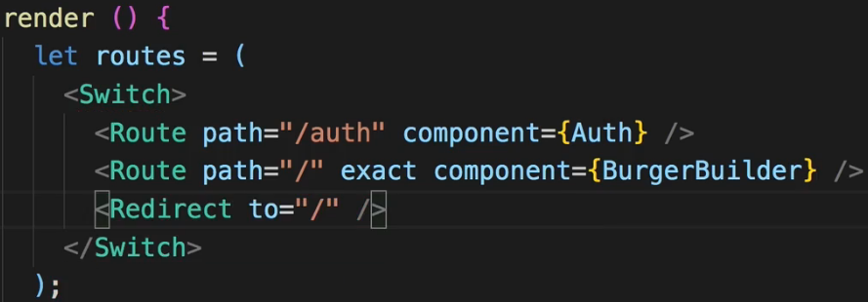  
* Now if we’re not authenticated, “/orders” redirects us to Burger Builder, Authenticate still works though because the Switch statement picks the first hit. But anything unknown, including “/orders”, which now is unknown because we don’t render that Route, redirects us back to the “/” main page.  
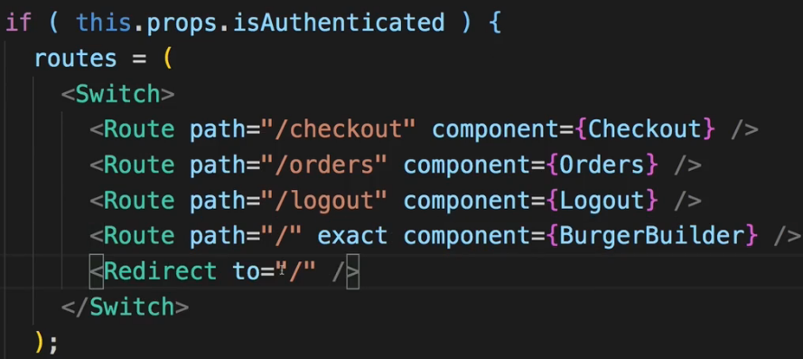  
* Let’s do the same for our authenticated routes.  
* With that we got GUARDS in place and we make sure we can’t visit pages we shouldn’t be able to.  
* Now 1 important note - since this of course is all JavaScript, people can of course always theoretically dig into your source code and still kind of manipulate it to still go to the protected route.  
=> This is why we have protection on the server.  
=> To not return any data for unauthenticated users.  
=> This is how you protect your data.  
=> The Frontend is only about providing a user experience that makes sense and to prevent the user from accidentally visitting a page he shouldn’t be able to visit, because he won’t be able to do anything on it.  
* So this is ROUTE Protection on the Frontend with GUARDS, now let’s move on to using our user data on our orders so that when we place an order when we’re authenticated, we do indeed use that.  
**Displaying User Specific Orders**  
* Thankfully the userId is stored in our `auth` slice of the state here:  
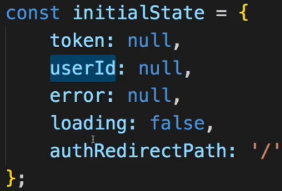  
=> So we’re storing that already, so we only need to make sure that we also take advantage of this when we place an order.  
* In order.js ACTION CREATORs:  
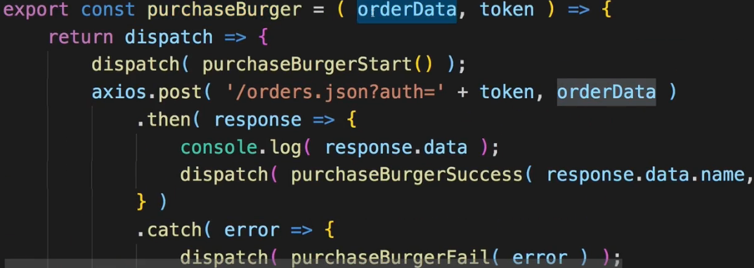  
=> Where we purchaseBurger, we want to pass the userId on to the Backend. So it should be part of the `orderData` I’d say.  
=> That, however, is set in our ContactData.js container, there in the orderHandler() we in the end dispatch() onOrderBurger, we call this function which dispatched the ACTION and there we set up our orderData. This is where I want to add the userId.  
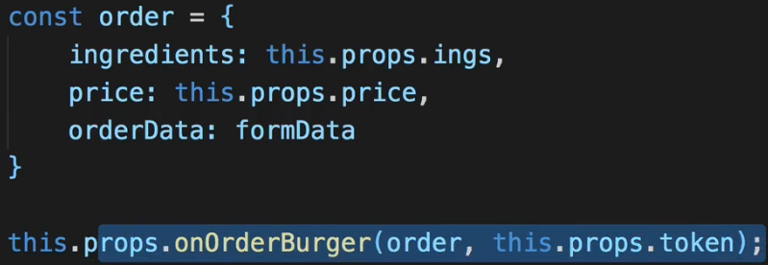  
=> Now since we store that in our Redux STORE, that’s super easy to do.  
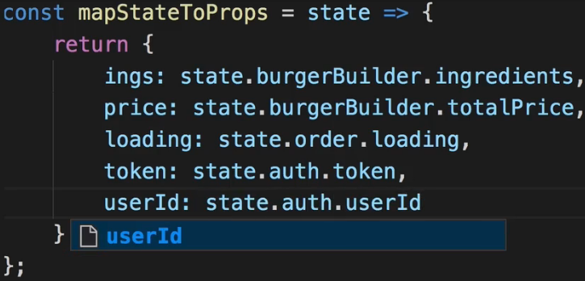  
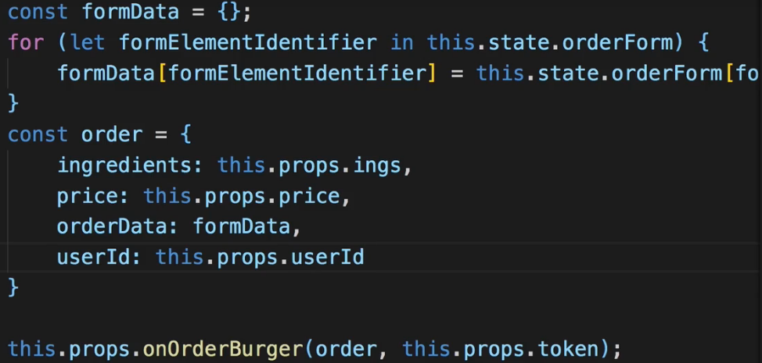  
* With that if I now place an order, this all seems to work, in the Backend the order was added and there we see that on the main element we have the userId.  
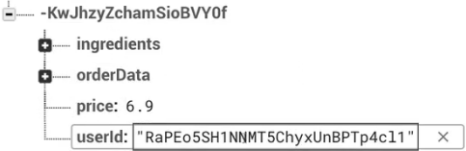  
* So now that order is mapped to our user.  
* Now of course we also want to make sure that when we visit orders, we only see orders of that user.  
* Now there are 2 ways of checking this:  
**=> 1 =>** One is on the Frontend because the data we get back from the Backend will hold this information, we can see this if we inspect our STATE in Redux Devtools for FETCH_ORDERS_SUCCESS.  
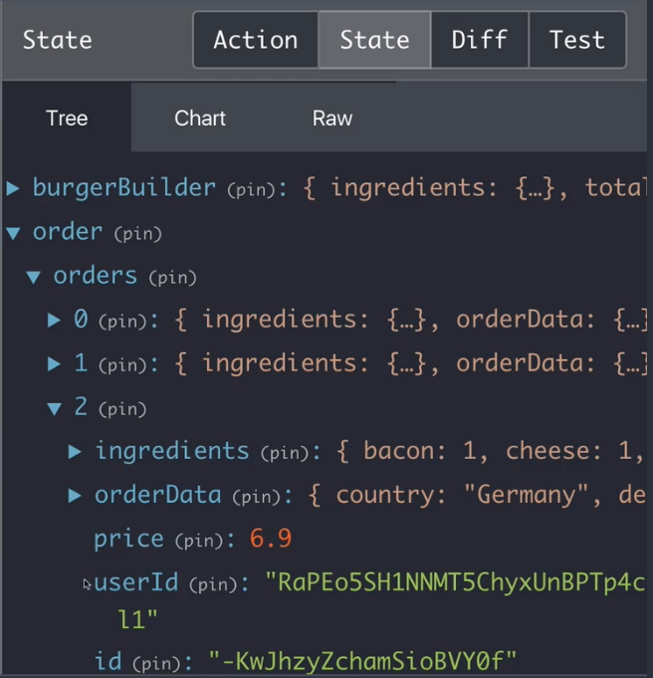  
=> We have the userId so we could check if that userId matches the ID of the logged in user.  
=> But we would still fetch all orders, and that’s a potential security issue because if anyone inspects our JavaScript code, he could see orders which aren’t meant for him.  
=> So a better way is to just fetch the orders we need from the Backend in the first place.  
=> And we can do that easily with Firebase, of course for your own API, you need some way of passing that userId to the Backend or use that TOKEN you pass along anyways, to only fetch data for a given user.  
* When using Firebase, you can easily filter data by going back to your Async ACTION CREATOR orders.js file and there where we have fetchOrders, we already pass the TOKEN, we can’t pass more query params here. And since I will add more, I’ll actually add a new const `queryParams` here and this will just be a string.  
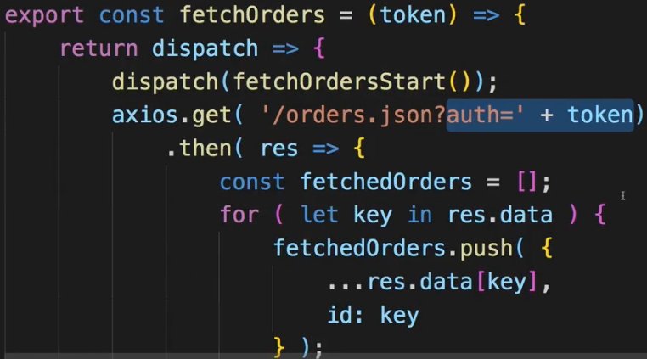  
* orderBy is a query param understood by Firebase which allow us to order our data. Now I actually don’t want to re-order it but this also tells Firebase: Hey, you can filter by that.  
=> So I want to orderBy my userId property.  
=> And now we can chain another query param, and that is equalTo - this also refers to the key you’re ordering by.  
* So we can say we want to order by that userId property on our Firebase data and we only want to fetch the data where this key -userId- is equal to: and here we expect to get the userId. We could of course also get it with that getState argument we can retrieve here but I don’t want to use that. Instead I expect to get the userId here as an argument and then here at my URL, I’ll replace the current code at the end by simply attaching my queryParams.  
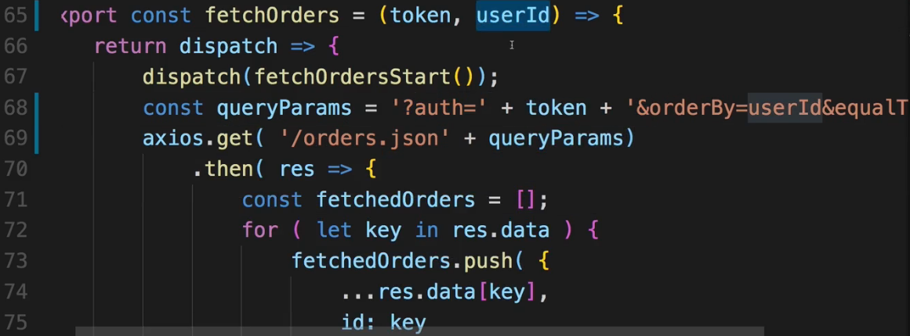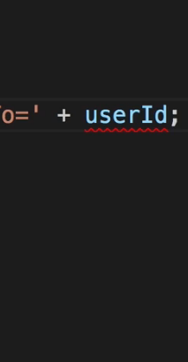  
* So let’s make sure we get the userId then.  
=> To do that, I need to go to the place where we execute `fetchOrders` or where we dispatch() this ACTION. And that of course happens in the Order.js container.  
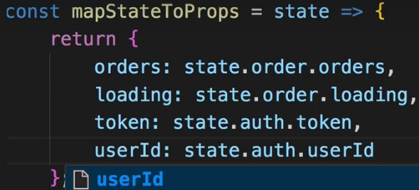  
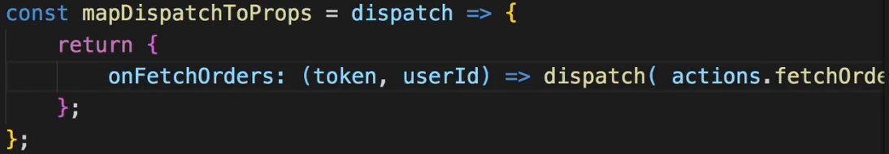  
* And then we have to pass it on in our container code too.  
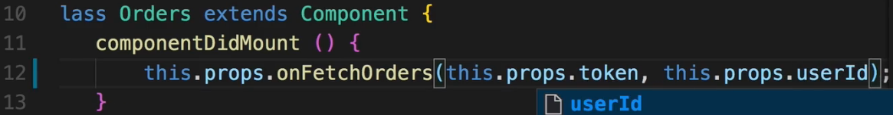  
* **Now if we go to “Orders”, I actually get a 400 error - Request failed with status code 400**.  
=> **The value of orderBy should be enclosed in “”**.  
=> **And the userId if it is a string and userId is a string, also needs to be wrapped with “”**.  
  
* Now we’re done with almost everything but we also need to prepare it on the Backend.  
* **Here in Firebase -that’s just Firebase specific- if you want to be able to filter data, we have to adjust our rules to make a certain field indexable, so that Firebase can reach through it**.  
* This is done in your rules tab on the Database.  
* You add “.indexOn” and now you can add an array of all the fields you want to make searchable.  
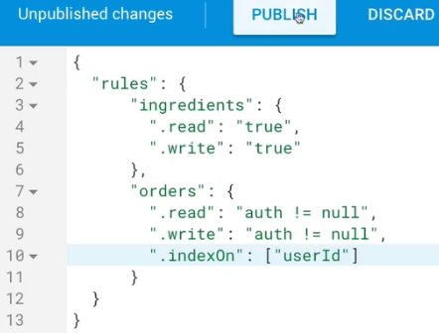  
* Now with that in place, and our code updated too, if we go back to the burger and we are logged in, we go to orders, we see only 1 order now, and that should be our order. If we order another one, we see that here too.  
* So now we only get that data and we have no chance of accessing data that doesn’t belong to our user.  
* Now of course this example is only showing it with Firebase but in your own Backend, you probably have your own foldering logic - either returning only user-related data from the server anyways by checking the TOKEN you pass along, or by also giving you some query functionality as we used it here.  
**Wrap Up**  
* Over this module, we covered a lot of ground.  
* We added so many functionalities to really make our application more secure.  
* We added authentication with validation, auto-signup, I showed you how to manage the TOKEN, and how to implement authentication in SPAs, we used our data to map our orders to a given user, we redirect the user when he tries to do something fishy, and much more.  
* You learned a lot of importanta concepts which you might need in your next React application too, so I hope this module was a great help with any future project you might face.  
**SPA Authentication in general**: <https://stormpath.com/blog/token-auth-spa>  
**Firebase authentication REST API**: <https://firebase.google.com/docs/reference/rest/auth/>